University of Maine
Job Description

TITLE: Structural Engineer III - V, Additive Manufacturing/Composites, US Persons Only
DEPARTMENT: Advanced Structures & Composites Center
DATE: November 9, 2021
REPORTS TO: Senior Program Manager

Introduction to the Advanced Structures and Composites Center
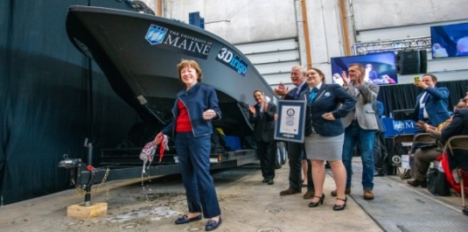
The Advanced Structures and Composites Center (ASCC) is a world-leading, interdisciplinary center for research, education, and economic development encompassing material sciences, advanced manufacturing and engineering of composites and structures. Housed in a 100,000ft² ISO-17025 accredited facility, the ASCC has been recognized nationally and internationally for cutting edge research programs leading and impacting new industries including offshore wind and marine energy, civil infrastructure, bio-based large-scale 3D printing, soldier protection systems and innovative defense-related applications. The ASCC is the largest university-based research Center in Maine, and one of the fastest growing research laboratories in the world, with research revenue growth of 5X in the past 5 years. Facility has expanded to include 13 integrated laboratories with more than 260 full and part time personnel, including faculty, staff and students. Since its founding in 1996 with support from the National Science Foundation, the Center has financially sponsored more than 2,600 students, received 70 patents, received over 26,000 visitors, created 14 spinoff companies through licensing of patents or trade secrets, and received more than 40 national and global awards for research excellence.
3Dirigo, a 25 ft. long, 5,000lbs patrol boat printed by UMaine in 72 hours, winning a Guinness World Record.
ASCC secured $150 million commitment to build a 10-12MW floating turbine using its patented VolturnUS technology.

The ASCC’s 2020 Strategic Plan, called GEM, focuses the Center’s work on Green Energy and Materials development. Through GEM, the Center is at the forefront of major new sustainability industries in the U.S., including these recent successful initiatives:

- Floating offshore wind technology developed at the ASCC led to a $100 million investment by global energy heavyweights Diamond Offshore Wind and RWE Renewables, and $50 million investment from the US DOE, to launch the first full-scale floating offshore wind project off the Maine coast. Read more about this accomplishment
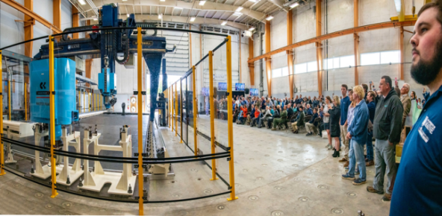
- Awarded three Guinness World Records for the world’s largest prototype polymer 3D printer, largest solid 3D-printed object, and largest 3D-printed boat. The awards came after ASCC printed 3Dirigo, a 25ft marine patrol vessel weighing 5,000lbs in under 3 days. Read more about this accomplishment
Largest polymer 3D printer in the world, commissioned at ASCC in Q4 2019. The print volume is 60 ft x 22ft x 10ft, and deposition rate is 150 lbs/hour
- First large-scale bio-based additive manufacturing program in the US, via a $20M additive manufacturing program with Oak Ridge National Lab to work with the forest products industry to produce new bio-based materials that will be conducive to 3D printing large-scale products such as boat hull molds, shelters, building components, tooling for composites and wind blades. Read more about this accomplishment
- Selected to lead the $14.2 million Transportation Infrastructure Durability Center with 5 other universities across New England to develop more sustainable, transformative and economical solutions to address our nation’s infrastructure challenges. Read more about this accomplishment

Purpose: The University of Maine Advanced Structures and Composites Center has an immediate need to hire a highly qualified Engineer III-V to support our continued growth in the areas of additive manufacturing, composite material development and applications, and bio-based materials. This position will support in designing and improving large scale additive manufacturing thermoplastic polymer composite structures and building components. The Engineer will manage and conduct a variety of research and development projects related to design, development and testing of large area additive manufactured composite structures and materials. The Engineer will also develop proposals for federal, state, and industry-funded R&D and demonstration programs, in cooperation with industry partners.

Essential Duties & Responsibilities:
Scope:
  - Conducts managerial duties in keeping research project on time and meeting objectives
  - Designs, manages and supervises engineering analysis, design and testing aspects for a variety of R&D projects with a specific focus on large area additive manufacturing
  - Recommends and designs tests to be conducted to fit the client’s needs
  - Manages manufacturing process development
  - Reviews processing methods and materials and develops and implements improvements
  - Develops and writes work instructions and executes drafts as required
  - Participates in providing weekly, quarterly and monthly progress reports to the program manager as well as to clients and sponsors
  - Writes industrial contract proposals and proposals for grants and other contracts
  - Writes patent applications
  - Writes and approves interim and final reports to clients and sponsors
  - Creates presentations of research and testing results and writes technical reports and papers for journals, periodicals, conferences, clients, sponsors and team members
  - Develops and maintains updated Gantt charts for projects
Impact:
  - Provides and reviews monthly progress reports to the program manager as well as to clients and sponsors
  - Position responsibilities and decisions toward final results impact the direction and/or success of the project or research funding.
  - Available guides or precedents are limited in decision making and errors are not typically apparent.
Contacts:
  - Instructs and advises professional and classified staff as well as undergraduate students referencing testing and execution techniques.
  - Communicates with vendors to establish purchase specifications for research and testing materials, non-capital equipment and capital equipment
  - Participates in conference calls, visits, and meetings with subcontractors, clients and sponsors
  - Has significant impact on the public image of the university because external relations with clients and industry partners. If issues or problems arise, the positive or negative consequences are likely to become widely known (internally and externally) and materially affect the reputation of the university.
Authority:
  - Supervises and guides a team of graduate research assistants and undergraduate student lab assistants
  - Assists and instructs multiple graduate and undergraduate students in area of expertise
  - Advises and assists graduate students in completing, executing and planning R&D projects
  - Coordinates teams and assigns tasks for completing research program plans
  - Provides safety and environmental management supervision and advice for graduate and undergraduate students
Fiscal Responsibility:
  - Monitors (reviews and checks for accuracy) program budgets totaling up to or exceeding $1M
  - Researches, recommends and determines specifications for purchase of minor non-capital equipment, materials and supplies for use in research projects
  - Analyzes (critically review budgetary data) program budgets totaling up to or exceeding $750K and recommends spending dollars accordingly
  - Administers (forecasts and controls spending) program budgets totaling up to or exceeding $150K and determines spending accordingly
Perform other reasonably related duties as assigned.

Knowledge & Skill Qualifications:

Required:
- M.S. in related Engineering field, mechanical engineering, civil engineering or related discipline with three years of relevant experience in a professional or academic research environment or an equivalent combination of education and experience
- EIT license and the ability to obtain PE within 1 year
- Significant experience in the analysis and design of structural composites
- Significant experience in the composites industries
- Excellent oral and written communication skills
- Demonstrated ability to manage multiple projects and meet constant deadlines
- Demonstrated ability to interact with industry members

Preferred:
- Experience in some of the following areas: advanced composites, finite element modeling, engineering design, advanced mechanics of materials (typically three - five years), additive manufacturing
- Experience in the building and construction industry
- Experience advising and directing student research

Position Type: Contingent on funding and successful performance.

Work Schedule: Normal University of Maine business hours are Monday through Friday 8:00 a.m. to 4:30 p.m. Due to the nature of the position, work beyond regular hours (to include evenings and weekends) will be necessary to meet the requirements of the position. The employee shall establish regular office hours and in consultation with the supervisor, adjust the work schedule as appropriate. This position is considered Essential Personnel in the ASCC Storm Day Policy.

Work Environment: Work will be performed at the Advanced Structures and Composites Center 100,000 ft2 laboratory with a world-leading team of over 150 faculty, staff and students who conduct contract research with a variety of public and private entities developing the next generation of low-cost, high performance composite materials.

Schedule for Evaluation: In the initial six months of employment and annually thereafter in accordance with the UMPSA agreement.

Salary: Engineer III – Salary Band 7 up to $112,816
Engineer IV – Salary Band 8 up to $129,738
Engineer V – Salary Band 9 up to $149,199

The finalist for this position must successfully complete a pre-employment physical.

All UMS employees are required to comply with applicable policies and procedures, as well as to complete applicable workplace related screenings, and required employee trainings, such as Information Security, Safety Training, Workplace Violence and Sexual Harassment.

Appropriate background checks will be required.

