University of Maine
Job Description

TITLE: Senior Grants and Contracts Administrator
DEPARTMENT: Advanced Structures & Composites Center
DATE: August 20, 2020
REPORTS TO: Senior Fiscal Officer, Grants Manager

Introduction to the Advanced Structures and Composites Center
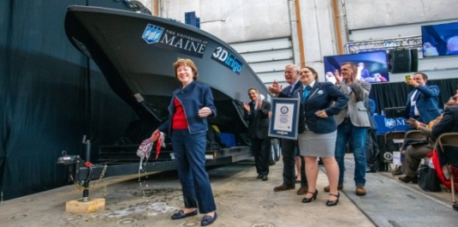
The Advanced Structures and Composites Center (ASCC) is a world-leading, interdisciplinary center for research, education, and economic development encompassing material sciences, advanced manufacturing and engineering of composites and structures. Housed in a 100,000ft² ISO-17025 accredited facility, the ASCC has been recognized nationally and internationally for cutting edge research programs leading and impacting new industries including offshore wind and marine energy, civil infrastructure, bio-based large-scale 3D printing, soldier protection systems and innovative defense-related applications. The ASCC is the largest university-based research Center in Maine, and one of the fastest growing research laboratories in the world, with research revenue growth of 5X in the past 5 years. Facility has expanded to include 13 integrated laboratories with more than 260 full and part time personnel, including faculty, staff and students. Since its founding in 1996 with support from the National Science Foundation, the Center has financially sponsored more than 2,600 students, received 70 patents, received over 26,000 visitors, created 14 spinoff companies through licensing of patents or trade secrets, and received more than 40 national and global awards for research excellence.
3Dirigo, a 25 ft. long, 5,000lbs patrol boat printed by UMaine in 72 hours, winning a Guinness World Record.
ASCC secured $150 million commitment to build a 10-12MW floating turbine using its patented VolturnUS technology.

The ASCC’s 2020 Strategic Plan, called GEM, focuses the Center’s work on Green Energy and Materials development. Through GEM, the Center is at the forefront of major new sustainability industries in the U.S., including these recent successful initiatives:

- Floating offshore wind technology developed at the ASCC led to a $100 million investment by global energy heavyweights Diamond Offshore Wind and RWE Renewables, and $50 million investment from the US DOE, to launch the first full-scale floating offshore wind project off the Maine coast. Read more about this accomplishment
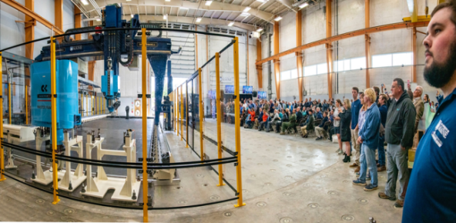
- Awarded three Guinness World Records for the world’s largest prototype polymer 3D printer, largest solid 3D-printed object, and largest 3D-printed boat. The awards came after ASCC printed 3Dirigo, a 25ft marine patrol vessel weighing 5,000lbs in under 3 days. Read more about this accomplishment
Largest polymer 3D printer in the world, commissioned at ASCC in Q4 2019. The print volume is 60 ft x 22ft x 10ft, and deposition rate is 150 lbs/hour
- First large-scale bio-based additive manufacturing program in the US, via a $20M additive manufacturing program with Oak Ridge National Lab to work with the forest products industry to produce new bio-based materials that will be conducive to 3D printing large-scale products such as boat hull molds, shelters, building components, tooling for composites and wind blades. Read more about this accomplishment
- Selected to lead the $14.2 million Transportation Infrastructure Durability Center with 5 other universities across New England to develop more sustainable, transformative and economical solutions to address our nation’s infrastructure challenges. Read more about this accomplishment
Purpose: ASCC has an immediate need for an experienced Senior Grants and Contracts Administrator to manage all aspects of the federal award lifecycle, from proposal preparation to contract administration and compliance to award close-out. ASCC’s external grants and contracts have grown 5X in the past 5 years and an increasing proportion of projects include complex or non-standard requirements. A dedicated Senior Contracts Administrator is required to both manage compliance and accuracy of new proposal submissions and proactively assess and ensure compliance with critical contract obligations and provisions in existing awards. This role will work closely with the UMaine Office of Research Administration (ORA) and Office of Research Compliance (ORC) by ensuring full compliance with UMaine’s research program guidance and high-quality, error-free and timely submissions. Position is intimately integrated with ORA/ORC, attends regular ORA/ORC meetings and trainings, reviews unique research & federal guidelines encountered by ASCC and makes related recommendations to ORA/ORC and the University.

Essential Duties and Responsibilities:

Scope:
- Administer prime contracts and subcontracts, including preparation and negotiation of proposals, contract administration, and contract close-out.
Proposal Preparation:
- Review solicitations and contractual documents and lead development of proposal responses including budget documents, ensuring consistency with UMaine policy, pertinent regulations, and customer requirements.
- Collaborate with Principle Investigators, Program Managers, Finance, ORA and ORC to examine contractual requirements, budgets, delivery schedules and project timelines and scrutinize all material, equipment and production costs to offer recommendations, improve compliance and promote budgetary responsibility.
Contract Administration and Compliance:
- Manage documentation and inquiries to assess risk and ensure compliance within UMaine’s contracting protocols and procedures and customer requirements.
- Provide oversight and resolve contractual issues that may arise in performance of the contract.
- Provide guidance to internal teams relating to all phases of the proposal submission and contract lifecycle.
- Ensures ASCC compliance with standard, complex and/or non-standard contracts and agreements, including all flow-through conditions, small business subcontracting plans, CFR, FAR/DFAR clauses, export control requirements, etc.
- Manages compliance with small business subcontracting plans.
Constituents and Contacts:
- Liaise with ORA, ORC and UMS Legal for review/approval of standard and unusual or non-standard terms and conditions and other contractual documents and agreements. Work closely with the UMaine Office of Research Administration (ORA) and Office of Research Compliance (ORC) by ensuring full compliance with UMaine’s research program guidance and high-quality, error-free and timely submissions. Attend regular ORA/ORC meetings and trainings.
- Develop positive working relationships with government counterparts while ensuring proper and timely contract performance.
- Develop skillset and knowledge to serve as domain expert on selected areas related to federal contracts and acquisition. Review unique research & federal guidelines encountered by ASCC and make related recommendations to ORA/ORC and the University.
Supervision:
- Operations Manager.
- Lead Fiscal Officer.

Knowledge and Skill Qualifications:

Required:
- Bachelor’s Degree in business administration or accounting or related field.
- U.S. Person.
- Strong attention to detail and the ability to multi-task in a dynamic, fast-paced environment.
- Ability to build collaborative business relationships both internal to the University and with external customers.
- Excellent oral and written communication skills.
- 8+ years’ experience in contracts administration, with some of that time supporting Federal and State Government contracts.
- Solid working knowledge of the Federal Acquisition Regulation (FAR), Defense Federal Acquisition. Regulations (DFAR), Code of Federal Regulations (CFR) related federal and state legislation and regulations, and the Uniform Commercial Code.
- Excellent computer skills including Excel, Powerpoint, accounting software, project management and enterprise management.

Preferred:
- MBA desirable.

Position Type: Ongoing, base budgeted.

Work Schedule: Normal University of Maine business hours are Monday through Friday 8:00 a.m. to 4:30 p.m. Work outside of regular business hours (to include nights and weekends) will be necessary at times in order to meet the requirements of the position. In consultation with the supervisor the employee will establish regular office hours and adjust work schedule as necessary. This position is considered Essential Personnel in the ASCC Storm Day Policy.

Work Environment: Work will be performed at the Advanced Structures and Composites Center 100,000 ft2 laboratory with a world-leading team of over 150 faculty, staff and students who conduct contract research with a variety of public and private entities developing the next generation of low-cost, high performance composite materials.

Schedule for Evaluation: In the initial six months of employment and annually thereafter in accordance with the UMPSA agreement.

Job Family/Salary Band: Salary Band 06 / Job Family 9.

All UMS employees are required to comply with applicable policies and procedures, as well as to complete applicable workplace related screenings, and required employee trainings, such as Information Security, Safety Training, Workplace Violence and Sexual Harassment.

Appropriate background checks will be required.

