University of Maine
Job Description

TITLE: Scientist I – Textiles
DEPARTMENT: Advanced Structures & Composites Center
DATE: March 2024
REPORTS TO: Scientist II

Introduction to the Advanced Structures and Composites Center
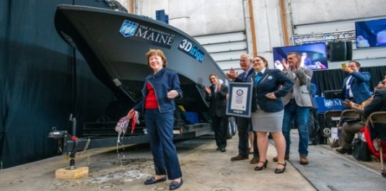
The Advanced Structures and Composites Center (ASCC) is a world-leading, interdisciplinary center for research, education, and economic development encompassing material sciences, advanced manufacturing and engineering of composites and structures. Housed in a 100,000ft² ISO-17025 accredited facility, the ASCC has been recognized nationally and internationally for cutting edge research programs leading and impacting new industries including offshore wind and marine energy, civil infrastructure, bio-based large-scale 3D printing, soldier protection systems and innovative defense-related applications. The ASCC is the largest university-based research Center in Maine, and one of the fastest growing research laboratories in the world, with research revenue growth of 5X in the past 5 years. Facility has expanded to include 13 integrated laboratories with more than 350 full and part time personnel, including faculty, staff, and students. Since its founding in 1996 with support from the National Science Foundation, the Center has financially sponsored more than 2,600 students, received 70 patents, received over 26,000 visitors, created 14 spinoff companies through licensing of patents or trade secrets, and received more than 40 national and global awards for research excellence.
3Dirigo, a 25 ft. long, 5,000lbs patrol boat printed by UMaine in 72 hours, winning a Guinness World Record.
ASCC secured $150 million commitment to build a 10-12MW floating turbine using its patented VolturnUS technology.

The ASCC’s 2020 Strategic Plan, called GEM, focuses the Center’s work on Green Energy and Materials development. Through GEM, the Center is at the forefront of major new sustainability industries in the U.S., including these recent successful initiatives:

- Floating offshore wind technology developed at the ASCC led to a $100 million investment by global energy heavyweights Diamond Offshore Wind and RWE Renewables, and $50 million investment from the US DOE, to launch the first full-scale floating offshore wind project off the Maine coast. Read more about this accomplishment
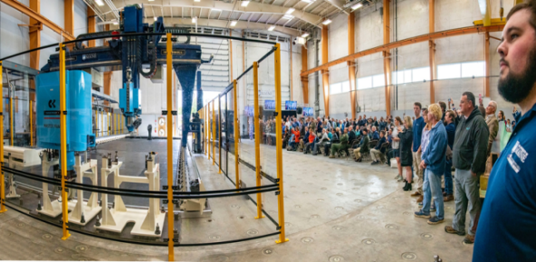
- Awarded three Guinness World Records for the world’s largest prototype polymer 3D printer, largest solid 3D-printed object, and largest 3D-printed boat. The awards came after ASCC printed 3Dirigo, a 25ft marine patrol vessel weighing 5,000lbs in under 3 days. Read more about this accomplishment
Largest polymer 3D printer in the world, commissioned at ASCC in Q4 2019. The print volume is 60 ft x 22ft x 10ft, and deposition rate is 150 lbs/hour.
- First large-scale bio-based additive manufacturing program in the US, via a $20M additive manufacturing program with Oak Ridge National Lab to work with the forest products industry to produce new bio-based materials that will be conducive to 3D printing large-scale products such as boat hull molds, shelters, building components, tooling for composites and wind blades. Read more about this accomplishment
- Selected to lead the $14.2 million Transportation Infrastructure Durability Center with 5 other universities across New England to develop more sustainable, transformative, and economical solutions to address our nation’s infrastructure challenges. Read more about this accomplishment

Purpose: The purpose of this position is to execute textiles research and development project assignments.

Essential Duties and Responsibilities:
- Scope
  - Designs and conducts tests, interprets, and analyzes data, writes reports and presents findings to team members.
  - Sets up and operates textile equipment.
  - Operates and maintains sophisticated scientific testing equipment to conduct research.
  - Develops and writes work instructions and executes changes in drafts as required.
  - Participates in providing periodic progress reports to the program manager as well as to clients and sponsors.
  - Assists in writing industrial contract proposals to obtain funding.
  - Assists in writing technical reports and papers detailing research and development activities for journals, periodicals, clients, and sponsors.
- Budget
  - Researches, recommends, and determines specifications for purchase of equipment, materials and supplies for use in research projects.
- Supervision
  - Supervises undergraduate students in research and laboratory activities.
  - Supervises operation and maintenance of testing equipment.
  - Instructs others in the use of equipment.
  - Provides safety and environmental management supervision and advice for undergraduate students.
- Contacts
  - Communicates with vendors to establish purchase specifications for research and testing materials, non-capital equipment and capital equipment.
  - Participates in meetings with clients.
  - As part of each project, interacts positively with a team of post-doctoral fellows, peers, Center laboratory staff, students, and faculty.
- Performs other reasonably related duties as assigned.

Knowledge and Skill Qualifications:
Required:
- Bachelor’s of Science in textiles, or related field.
- Experience or training on industrial knitting and weaving machines.
- Good oral and written communication skills.
- Demonstrated ability to handle multiple projects and constant deadlines.
- Ability to work independently as well as in a team environment with faculty, post-doctoral fellows, lab technicians, management, students, and research sponsors.

Preferred:
- Experience in some of the following areas: textile engineering and design, knitting, weaving (dobby and/or jacquard), and fiber extrusion.
- Hands-on experience operating textile equipment or working in a textile manufacturing environment.
- Experience in student research.

Position Type: Contingent on funding and successful performance.

Work Schedule: Normal University of Maine business hours are Monday through Friday 8:00 a.m. to 4:30 p.m. Due to the nature of the position, work beyond regular hours (to include evenings and weekends) will be necessary to meet the requirements of the position. The employee shall establish regular office hours and in consultation with the supervisor, adjust the work schedule as appropriate.

Work Environment: Work will be performed at the Advanced Structures and Composites Center 87,000 ft2 laboratory with a world-leading team of over 350 faculty, staff and students who conduct contract research with a variety of public and private entities developing the next generation of low-cost, high performance composite materials.

Schedule for Evaluation: In the initial six months of employment and annually thereafter in accordance with the UMPSA agreement.

Job Family 06 / Salary Band 03

The finalist for this position must successfully complete a pre-employment physical. Appropriate background checks will be required.

All UMS employees are required to comply with applicable policies and procedures, as well as to complete applicable workplace related screenings, and required employee trainings, such as Information Security, Safety Training, Workplace Violence and Sexual Harassment.

