University of Maine
Job Description
US PERSON ONLY – CONTROLLED PROJECTS

TITLE: Safety and Training Manager
DEPARTMENT: Advanced Structures and Composites Center
DATE: 2/15/2022
REPORTS TO: Lab Operations Manager

Introduction to the Advanced Structures and Composites Center
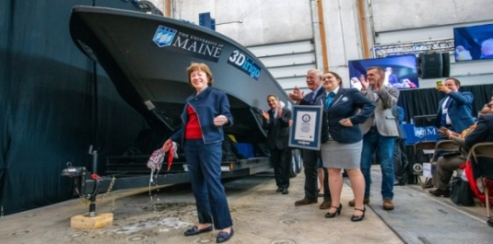
The Advanced Structures and Composites Center (ASCC) is a world-leading, interdisciplinary center for research, education, and economic development encompassing material sciences, advanced manufacturing and engineering of composites and structures. Housed in a 100,000ft² ISO-17025 accredited facility, the ASCC has been recognized nationally and internationally for cutting edge research programs leading and impacting new industries including offshore wind and marine energy, civil infrastructure, bio-based large-scale 3D printing, soldier protection systems and innovative defense-related applications. The ASCC is the largest university-based research Center in Maine, and one of the fastest growing research laboratories in the world, with research revenue growth of 5X in the past 5 years. Facility has expanded to include 13 integrated laboratories with more than 260 full and part time personnel, including faculty, staff and students. Since its founding in 1996 with support from the National Science Foundation, the Center has financially sponsored more than 2,600 students, received 70 patents, received over 26,000 visitors, created 14 spinoff companies through licensing of patents or trade secrets, and received more than 40 national and global awards for research excellence.
3Dirigo, a 25 ft. long, 5,000lbs patrol boat printed by UMaine in 72 hours, winning a Guinness World Record.

The ASCC’s 2020 Strategic Plan, called GEM, focuses the Center’s work on Green Energy and Materials development. Through GEM, the Center is at the forefront of major new sustainability industries in the U.S., including these recent successful initiatives:
ASCC received $150 million commitment from private investors and the US DOE to build a 10-12MW floating turbine using its patented VolturnUS technology.

- Floating offshore wind technology developed at the ASCC led to a $100 million investment by global energy heavyweights Diamond Offshore Wind and RWE Renewables, and $50 million investment from the US DOE, to launch the first full-scale floating offshore wind project off the Maine coast. Read more about this accomplishment
- Awarded three Guinness World Records for the world’s largest prototype polymer 3D printer, largest solid 3D-printed object, and largest 3D-printed boat. The awards came after ASCC printed 3Dirigo, a 25ft marine patrol vessel weighing 5,000lbs in under 3 days. Read more about this accomplishment
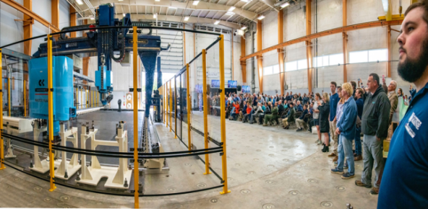
- First large-scale bio-based additive manufacturing program in the US, via a $20M additive manufacturing program with Oak Ridge National Lab to work with the forest products industry to produce new bio-based materials that will be conducive to 3D printing large-scale products such as boat hull molds, shelters, building components, tooling for composites and wind blades. Read more about this accomplishment
Largest polymer 3D printer in the world, commissioned at ASCC in Q4 2019. The print volume is 60 ft x 22ft x 10ft, and deposition rate is 150 lbs/hour
- Selected to lead the $14.2 million Transportation Infrastructure Durability Center with 5 other universities across New England to develop more sustainable, transformative and economical solutions to address our nation’s infrastructure challenges. Read more about this accomplishment

Purpose: The purpose of this position is to oversee all safety at the Advanced Structures and Composites Center. This includes supervisory responsibility for staff and students in the laboratory.

Essential Duties and Responsibilities:
- Scope
  - Functions as a safety specialist for Advanced Structures and Composites Center and is responsible for all safety programs and protocols at the Center including management and upgrades to safety procedures
  - Monitors laboratory activities to ensure safety and operational procedures are being followed (e.g. work instructions and hazard assessments are in place and adhered to)
  - Manages all aspects of ASCC’s safety training programs
  - Ensures Center compliance with all OSHA and SEM safety regulations
  - Operate a variety of standard and specialized technical equipment
  - Makes recommendations for improvements of internal methods and operations and carries out the actions necessary for implementation
  - Reviews and approves work instructions for all projects and recommends changes as technology develops and/or to ensure quality and safety for Staff and students
  - Stays abreast of developments in safety
- Supervision
  - May supervises student employees in the laboratory ensuring proper equipment handling and safe and proper execution of project-related duties
  - Instructs students in the safe use of equipment
- Contacts
  - Frequent interdepartmental contact to maintain lab and building facilities, including at the highest level of Facilities Management and Safety and Environmental Management
  - Communicates with vendors to establish purchase specifications for laboratory materials and non-capital equipment
  - As part of each project, interacts positively with a team of post-doctoral fellows, peers, Advanced Structures and Composites Center laboratory staff, students and faculty

- Performs other reasonably related duties as assigned

Knowledge and Skill Qualifications:
Required:
- B.S. in Engineering Technology with more than three years of relevant experience or equivalent combination of education and experience typically associated with a Bachelor’s Degree
- Familiar with databases (preferable MS Access), spreadsheets (MS Excel), word processing (MS Word)
- Excellent organizational, oral and written communication skills
- Trained in safe work practices around power tools and large equipment, and ability to train others in these practices
- Experience with hydraulic testing equipment (preferably Instron and/or MTS systems)
- Possesses a background in structural testing and implementation of appropriate safety protocols for structural testing projects.
- Ability to work independently as well as in a team environment with faculty, post-doctoral fellows, lab technicians, management, students, and research sponsors

Preferred:
- Minimum 5 years of experience with composites manufacturing and testing techniques
- Experience in supervision of students and staff
- OSHA 30 Certification

Position Type: Contingent on funding and successful performance.

Work Schedule: Normal University of Maine business hours are Monday through Friday 8:00 am to 4:30 pm. Work outside of normal business hours will be necessary in order to complete the requirements of the position.

Work Environment: Work will be performed at the Advanced Structures and Composites Center 100,000 ft² laboratory with a world-leading team of over 150 faculty, staff, and students who conduct contract research with a variety of public and private entities developing the next generation of low-cost, high performance composite materials.

Schedule for Evaluation: In the initial six months of employment and annually thereafter in accordance with the UMPSA agreement.

Job Family/Salary Band: 02/04.

The finalist for this position must complete a pre-employment physical and appropriate background checks will be required.

All UMS employees are required to comply with applicable policies and procedures, as well as to complete applicable workplace related screenings, and required employee trainings, such as Information Security, Safety Training, Workplace Violence and Sexual Harassment.

