University of Maine

Job Description

TITLE: Research Engineer IV – Advanced Manufacturing

DEPARTMENT: Advanced Structures and Composites Center

DATE: February 2024

REPORTS TO: Senior Research Lead

Introduction to the Advanced Structures and Composites Center
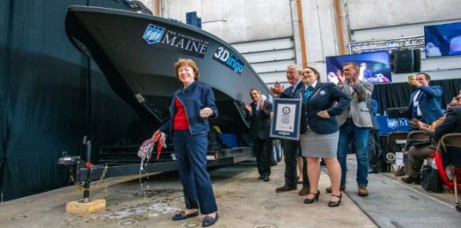
The Advanced Structures and Composites Center (ASCC) is a world-leading, interdisciplinary center for research, education, and economic development encompassing material sciences, advanced manufacturing and engineering of composites and structures. Housed in a 100,000ft² ISO-17025 accredited facility, the ASCC has been recognized nationally and internationally for cutting edge research programs leading and impacting new industries including offshore wind and marine energy, civil infrastructure, bio-based large-scale 3D printing, soldier protection systems and innovative defense-related applications. The
ASCC is the largest university-based research Center in Maine, and one of the fastest growing research laboratories in the world, with research revenue growth of 5X in the past 5 years. Facility has expanded to include 13 integrated laboratories with more than 260 full and part time personnel, including faculty, staff, and students. Since its founding in 1996 with support from the National Science Foundation, the Center has financially sponsored more than 2,600 students, received 70 patents, received over
26,000 visitors created 14 spinoff companies through licensing of patents or trade secrets and received more than 40 national and global awards for research excellence.
3Dirigo, a 25 ft. long, 5,000lbs patrol boat
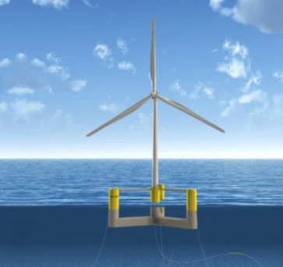
printed by UMaine in 72 hours, winning a Guinness World Record.

The ASCC’s 2020 Strategic Plan, called GEM, focuses the Center’s work on Green Energy and Materials development. Through GEM, the Center is at the forefront of major new sustainability industries in the U.S., including these recent successful initiatives:

- Floating offshore wind technology developed at the ASCC led to a $100 million investment by global energy heavyweights Diamond Offshore Wind and RWE Renewables, and $50 million investment from the US DOE, to launch the first full- scale floating offshore wind project off the Maine coast. Read more about this accomplishment
- Awarded three Guinness World Records for the world’s largest prototype polymer

ASCC secured $150 million commitment to build a 10- 12MW floating turbine using its patented VolturnUS technology.

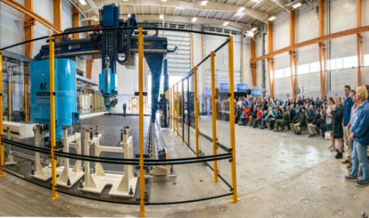
3D printer, largest solid 3D-printed object, and largest 3D-printed boat. The awards came after ASCC printed 3Dirigo, a 25ft marine patrol vessel weighing 5,000lbs in under 3
days. Read more about this accomplishment
- First large-scale bio-based additive manufacturing program in the US, via a $20M additive manufacturing program with Oak Ridge National Lab to work with the forest products industry to produce new bio-based materials that will be conducive to 3D printing large-scale products such as boat hull molds, shelters, building components, tooling for composites and wind blades. Read more about this accomplishment

- Selected to lead the $14.2 million Transportation Infrastructure Durability Center with 5 other universities across New England to develop more sustainable, transformative, and economical solutions to address our nation’s infrastructure challenges. Read more about this accomplishment
Largest polymer 3D printer in the world, commissioned at ASCC in Q4 2019. The print volume is 60 ft x 22ft x 10ft, and deposition rate is 150 lbs/hour.

Purpose: The purpose of this position is to execute engineering research and development project assignments.

Essential Duties & Responsibilities:
Technical Competency
  - Design and conduct tests, interpret and analyze data.
  - Develop custom and adapt existing test methods for new applications.
  - Operate manufacturing and scientific testing equipment to produce and characterize test samples.
  - Apply engineering knowledge to develop concept, prototype, and test designs.
  - Develop Technical Data Packages.
  - Perform engineering calculations to determine relevant design and performance parameters.
  - Conduct trade space exploration studies.
  - Contribute to the development of design specifications.
  - Detailed Conceptual Design capabilities.
  - Set up and execute complex numerical analyses to answer research questions.
  - Contribute to the development of custom solutions within existing modeling frameworks.
  - Experience with programming languages such as Python, MATLAB, C++, etc.
  - Significantly contribute to the development of new libraries to solve engineering and data analysis. research problems.
  - Conduct literature reviews to extract information to determine gaps and opportunities for research.
  - Develop thesis to explain observed phenomena and corresponding research plans to investigate and test them.
  - Develop and justify research assumptions and constraints.
  - Contribute to the development of task and resource planning.
  - Contribute to the development of research proposals.
  - Develop invention disclosures and patent applications for novel technologies.
  - Independently write technical reports and progress updates and present results to research partners and stakeholders.
  - Draft conference and journal papers.
  - Develop Standard Work Instructions and SOP’s.
  - Present research results at professional meetings.
  - Review technical work and writing for quality.
  - Complete assigned tasks with high quality

Self-Management
  - Coordinate research tasking resources and timelines to meet research objectives.
  - Independently develop research problem and tasking ideas.
  - Implement improvements in research and organizational operations.
  - Develop novel concepts for new technologies and generate corresponding invention disclosures.

Teamwork
  - Provide technical leadership and technique consultation.
  - Participate in the evaluation and approval of trainees.
  - Participate in the evaluation and approval of trainees.
  - Provide subject matter expertise and mentoring to members of the Manufacturing Hardware & Design functional group.
  - Provide technical feedback and guidance to team members to promote high quality research.
  - Provide guidance regarding the use of design specifications.
  - Provide oversight to research efforts.

Continued Education
  - Pursue advanced educational and training opportunities.

  - Learn new skills and technologies as requirements of the position.
  - Keep informed with the latest advancements in technology by attending webinars, trainings, etc.
  - Attend professional meetings such as conferences.

Knowledge & Skill Qualifications:
Required:
  - M.S. with equivalent experience.
  - Significant professional experience in some of the following areas required: advanced composites, finite element modeling, engineering design, advanced mechanics of materials.
  - Excellent oral and written communications skills.
  - Demonstrated ability to handle multiple projects and constant deadlines.

Preferred:
  - Ph.D. in Mechanical Engineering or related field.
  - EIT License.

Position Type: Contingent on funding and successful performance.

Work Schedule: Normal University of Maine business hours are Monday through Friday 8:00 a.m. to 4:30p.m. Due to the nature of the position, work beyond regular hours (to include evenings and weekends) will be necessary to meet the requirements of the position. The employee shall establish regular office hours and in consultation with the supervisor, adjust the work schedule as appropriate. This position is considered Essential Personnel in the ASCC Storm Day Policy.
Work Environment: Work will be performed at the Advanced Structures and Composites Center 100,000 ft2 laboratory with a world-leading team of over 350 faculty, staff and students who conduct contract research with a variety of public and private entities developing the next generation of low-cost, high performance composite materials.

Schedule for Evaluation: In the initial six months of employment and annually thereafter in accordance with the UMPSA agreement.
Job Family: 07 / Salary Band 08.

Appropriate background checks and post-offer physical will be required.

All UMS employees are required to comply with applicable policies and procedures, as well as to complete applicable workplace related screenings, and required employee trainings, such as Information Security, Safety Training, Workplace Violence and Sexual Harassment.

