Professional Employment
UNIVERSITY OF MAINE

Job Description

Title: Postdoctoral Research Associate in Materials, Processing and Modeling for Additive Manufacturing (ARP 1)
Date: 4-12-21
Lead Research Unit: Advanced Structures and Composites Center
Reports to: Professor (Faculty Mentor), Co-Principal Investigator

Introduction to the Advanced Structures and Composites Center
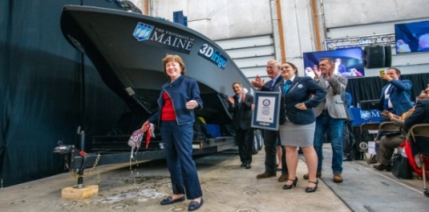
The Advanced Structures and Composites Center (ASCC) is a world-leading, interdisciplinary center for research, education, and economic development encompassing material sciences, engineering, and advanced manufacturing of composites and structures. Housed in a 100,000 ft² ISO-17025 accredited facility, the ASCC has been recognized nationally and internationally for cutting edge research programs leading and impacting new industries including offshore wind and marine energy, civil infrastructure, bio-based large-scale 3D printing, soldier protection systems, and innovative defense-related applications. The ASCC is the largest university-based research center in Maine, and one of the fastest growing research laboratories in the world, with research revenue growth of 5X in the past 5 years. The facility has expanded to include 13 integrated laboratories with more than 260 full and part time personnel, including faculty, staff, and students. Since its founding in 1996 with support from the National Science Foundation, the Center has financially sponsored more than 2,600 students, received 70 patents, received over 26,000 visitors, created 14 spinoff companies through licensing of patents or trade secrets, and received more than 40 national and global awards for research excellence.
3Dirigo, a 25 ft. long, 5,000 lbs. patrol boat printed by UMaine in 72 hours, winning a Guinness World Record.

The ASCC’s 2020 Strategic Plan, called GEM, focuses the Center’s work on Green Energy and Materials development. Through GEM, the Center is at the forefront of major new sustainability industries in the U.S., including these recent successful initiatives:
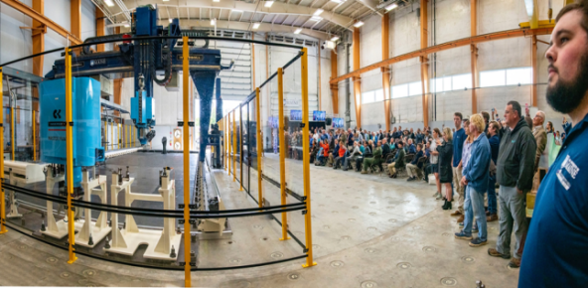
Largest polymer 3D printer in the world, commissioned at ASCC in Q4 2019. The print volume is 60 ft x 22 ft x 10 ft, and deposition rate is 150 lbs./hour.
- First large-scale bio-based additive manufacturing program in the US, via a $20M additive manufacturing program with Oak Ridge National Lab to work with the forest products industry to produce new bio-based materials that will be conducive to 3D printing large-scale products such as boat hull molds, shelters, building components, tooling for composites, and wind blades. Read more about this accomplishment
- Floating offshore wind technology developed at the ASCC led to a $100M investment by global energy heavyweights Diamond Offshore Wind and RWE Renewables, and $50M investment from the US DOE, to launch the first full-scale floating offshore wind project off the Maine coast. Read more about this accomplishment
ASCC received $150M commitment from private investors and the US DOE to build a 10-12 MW floating turbine using its patented VolturnUS technology.
- Awarded three Guinness World Records for the world’s largest prototype polymer 3D printer, largest solid 3D-printed object, and largest 3D-printed boat. The awards came after ASCC printed 3Dirigo, a 25-ft marine patrol vessel weighing 5,000 lbs. in under 3 days. Read more about this accomplishment
- Selected to lead the $14.2M Transportation Infrastructure Durability Center with 5 other universities across New England to develop more sustainable, transformative, and economical solutions to address our nation’s infrastructure challenges. Read more about this accomplishment
Engage with world-leading experts and researchers
Access state-of-the-art equipment and facilities
Build your career as a PI/Co-PI
Live in beautiful Maine
Build a Meaningful and Successful Career in Research
PURPOSE: There is an immediate opening for a highly-qualified Postdoctoral Research Associate to support a research program aimed at merging high performance computing (HPC) with large-area additive manufacturing (LAAM) of thermoplastic composite materials and structures. Research activities include development and evaluation of computational tools and methods that will support future realization of a process-informed, physics-based, and HPC-enabled computational framework for LAAM. Such a framework is expected to have the ability to (a) predict the post-fabrication properties and response characteristics of the printed product, (b) optimize the product design and the manufacturing process, and (c) facilitate in-situ monitoring and data feedback for process adjustments by incorporating machine learning and artificial intelligence (AI), thereby enhancing product performance.
The Postdoctoral Research Associate will support, plan, and conduct assigned and original research encompassing experimental characterization and computational modeling of LAAM based on the fused deposition process as well as integrated product-process design informed by material-process-property models, while working collaboratively with faculty, staff, as well as graduate and undergraduate students at the Advanced Structures and Composites Center, and the UMaine academic departments.
Postdoctoral Research Associates (post docs) are professional employees covered by the UMPSA contract. Post doc appointments at the University of Maine are for a limited duration and must include an educational component. University policy requires that a University of Maine faculty member be identified as a mentor and that specific guidelines be met. The purpose of the post doc appointment is to further prepare an individual who was recently awarded a doctorate to undertake the responsibilities of a career in research.

ESSENTIAL DUTIES/RESPONSIBILITIES:
- Develop, implement, and evaluate thermo-mechanical models for advancing the understanding of large-scale fused deposition of thermoplastics and composites
- Perform computational simulations involving multi-scale models
- Maintain accurate records of research findings and the analysis of results
- Present and report research results and publish scientific results in peer-reviewed journals in a timely fashion
- Lead and participate in writing publications and patent applications
- Mentor graduate students and undergraduate students, as appropriate
- Ensure compliance with environmental, health, and safety requirements
- Adhere to and foster the ethical practice of science and engineering

To ensure that post docs have meaningful guidance and support during this phase of career preparation, the Faculty Mentor will:
- Define and direct research tasks in areas that will broaden the experience and expertise of the postdoctoral research associate in preparation for a career in research
- Monitor progress of the postdoctoral research associate through regular (at least weekly) one-on-one meetings
- Encourage and aid the postdoctoral research associate in publishing and presenting research results to the international community of experts in the field
- Instruct the postdoctoral research associate in funding and proposal writing strategies
- Write recommendation letters and aid in job searches during the final stages of the postdoctoral research appointment
- Conduct performance evaluations as specified in the UMPSA Agreement (PDF)

KNOWLEDGE AND SKILLS QULAIFICATIONS:

REQUIRED:
- PhD in Materials Science, Materials Engineering, Mechanical Engineering, Civil Engineering, or a related discipline completed within the last 5 years
- Prior coursework or research in additive manufacturing, composites, or solid mechanics
- Experience with finite-element modeling of process-dependent solutions to thermo-mechanical problems
- Experience with experimental methods for characterization of composite materials
- Experience with processing thermoplastic polymer composite materials

PREFERRED:
- Experience with polymer-matrix composites manufacturing
- Experience with finite element modeling
- Experience with additive manufacturing
- Experience with experimental characterization methods
- Experience with modeling and simulation of thermo-mechanical problems
- Experience designing and conducting experiments for the development and validation of predictive models
- An excellent record of productive and creative research as demonstrated by publications in peer-reviewed journals and conference proceedings
- Excellent written and oral communication skills
- Ability to work with and mentor graduate and undergraduate students, as well as set priorities to accomplish multiple tasks within deadlines

SUPERVISORY RESPONSIBILITIES: Undergraduate Research Assistants and Graduate Research Assistants.

POSITION TYPE: Contingent on funding and successful performance. In accordance with policy, the overall maximum duration of a Postdoctoral Research Associate appointment is five years.

WORK YEAR: Fiscal-year.

WORK SCHEDULE: Normal University of Maine business hours are Monday through Friday 8:00 a.m. to 4:30 p.m. Work outside of normal business hours will be necessary in order to complete the requirements of the position.

WORK ENVIRONMENT: Work will be performed at the Advanced Structures and Composites Center with over 230 faculty, staff and students conducting contract research with a variety of public and private entities as well as in the UMaine academic departments.

SCHEDULE FOR EVALUATION: In the initial six months of employment and annually thereafter in accordance with the UMPSA agreement.

The finalist for this position must successfully complete a pre-employment physical, and appropriate background checks will be required.

All UMS employees are required to comply with applicable policies and procedures, as well as to complete applicable workplace related screenings, and required employee trainings, such as Information Security, Safety Training, Workplace Violence and Sexual Harassment.

