University of Maine
Job Description

Title: Postdoctoral Research Associate – Cellulosic Material Production, Processing and Applications
Lead Research Unit: Advanced Structures and Composites Center
Date: December 2020
Reports To: Program Managers, Principal Investigators

Introduction to the Advanced Structures and Composites Center
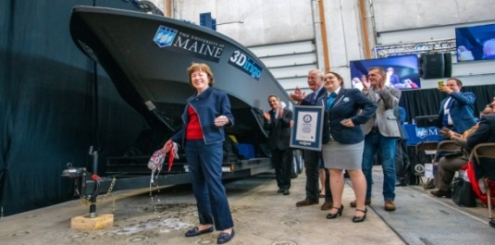
The Advanced Structures and Composites Center (ASCC) is a world-leading, interdisciplinary center for research, education, and economic development encompassing material sciences, advanced manufacturing and engineering of composites and structures. Housed in a 100,000ft² ISO-17025 accredited facility, the ASCC has been recognized nationally and internationally for cutting edge research programs leading and impacting new industries including offshore wind and marine energy, civil infrastructure, bio-based large-scale 3D printing, soldier protection systems and innovative defense-related applications. The ASCC is the largest university-based research center in Maine, and one of the fastest growing research laboratories in the world, with research revenue growth of 5X in the past 5 years. The facility has expanded to include 13 integrated laboratories with more than 260 full and part time personnel, including faculty, staff and students. Since its founding in 1996 with support from the National Science Foundation, the Center has financially sponsored more than 2,600 students, received 70 patents, received over 26,000 visitors, created 14 spinoff companies through licensing of patents or trade secrets, and received more than 40 national and global awards for research excellence.
3Dirigo, a 25 ft. long, 5,000lbs patrol boat printed by UMaine in 72 hours, winning a Guinness World Record.

The ASCC’s 2020 Strategic Plan, called GEM, focuses the Center’s work on Green Energy and Materials development. Through GEM, the Center is at the forefront of major new sustainability industries in the U.S., including these recent successful initiatives:
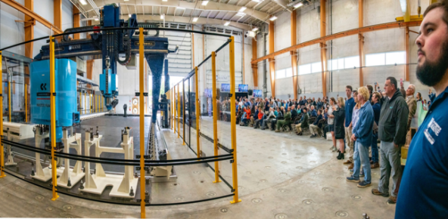
Largest polymer 3D printer in the world, commissioned at ASCC in Q4 2019. The print volume is 60 ft x 22ft x 10ft, and deposition rate is 150 lbs/hour
- First large-scale bio-based additive manufacturing program in the US, via a $20M additive manufacturing program with Oak Ridge National Lab to work with the forest products industry to produce new bio-based materials that will be conducive to 3D printing large-scale products such as boat hull molds, shelters, building components, tooling for composites and wind blades. Read more about this accomplishment
- Floating offshore wind technology developed at the ASCC led to a $100 million investment by global energy heavyweights Diamond Offshore Wind and RWE Renewables, and $50 million investment from the US DOE, to launch the first full-scale floating offshore wind project off the Maine coast. Read more about this accomplishment
- Awarded three Guinness World Records for the world’s largest prototype polymer 3D printer, largest solid 3D-printed object, and largest 3D-printed boat. The awards came after ASCC printed 3Dirigo, a 25ft marine patrol vessel weighing 5,000lbs in under 3 days. Read more about this accomplishment
ASCC received $150 million commitment from private investors and the US DOE to build a 10-12MW floating turbine using its patented VolturnUS technology.
- Selected to lead the $14.2 million Transportation Infrastructure Durability Center with 5 other universities across New England to develop more sustainable, transformative and economical solutions to address our nation’s infrastructure challenges. Read more about this accomplishment
Engage with world-leading experts and researchers
Access state-of-the-art equipment and facilities
Build your career as a PI/Co-PI
Live in beautiful Maine

PURPOSE: The University of Maine Advanced Structures and Composites Center has an immediate need to hire a highly-qualified Postdoctoral Research Associate to support a high-profile national partnership develop sustainable, bio-based materials for large-scale additive manufacturing. The Postdoctoral Research Associate will support, plan, and conduct assigned and/or original research in a variety of research and development projects encompassing material sciences, manufacturing, and the engineering of composites and structures while working collaboratively with faculty, staff, and graduate and undergraduate students at the Advanced Structures and Composites Center and the UMaine Process Development Center.
ESSENTIAL DUTIES/RESPONSIBILITIES:

- Lead major federal and industry research projects as Principal Investigator/Co-PI, directing technical research tasks and managing all aspects of award lifecycle.
- Conduct research and development of novel mechanical fibrillation methods for the sustainable production of nanoscale cellulosic materials.
- Review, identify and propose novel candidate technologies for mechanical fibrillation of cellulose-based materials.
- Identify methods for and conduct characterization of cellulosic nanomaterials, including structure and properties.
- Assess fibrillation efficiency and reproducibility of proposed methods.
- Assess scalability of promising systems and determine overall cost.
- Present and report research results and publish scientific results in peer-reviewed journals in a timely fashion.
- Ensure compliance with environmental, health, and safety requirements.
- Lead and participate in writing publications and patent applications.
- Supervise and lead teams of research engineers, graduate and undergraduate students.
- Adhere to and foster the ethical practice of science.

TECHNICAL QUALIFICATIONS:

- PhD in Chemical Engineering, Materials Science, Polymer Science, Wood Science, Mechanical Engineering or a related discipline completed within the last 5 years.
- Experience with fiber reinforced polymer (FRP) composites and modification and nanocomposite processing.
GENERAL REQUIREMENTS

- Experience with cellulose micro/nanofiber production.
- Experience with extrusion, injection molding, compression molding.
- Experience with 3D printing (material deposition, FDM).
- Experience with emulsion, suspension, and/or aqueous polymerizations.
- Experience with processing pulp, biomass, and/or fibers through mechanical refining.
- Experience with pilot scale reactions and/or refining.
- Experience with chemical and physical characterization of polymers and materials using techniques such as DSC, FTIR, TGA, DMA, EDS, XRD, Rheology, electron and optical microscopy.
- An excellent record of productive and creative research as demonstrated by publications in peer-reviewed journals.
- Excellent written and oral communication skills to communicate in English to an international scientific audience.
- The desire and ability to work with and mentor others as well as set priorities to accomplish multiple tasks within deadlines.

SUPERVISORY RESPONSIBILITIES: Undergraduate Research Assistants, Graduate Research Assistants and Engineering Staff.

POSITION TYPE: Contingent on funding and successful performance. Overall maximum duration of Postdoctoral position is five years.

WORK SCHEDULE: Normal University of Maine business hours are Monday through Friday 8:00 a.m. to 4:30 p.m. Work outside of normal business hours will be necessary in order to complete the requirements of the position.

WORK ENVIRONMENT: Work will be performed at the Advanced Structures and Composites Center 100,000 ft² laboratory with a world-leading of over 230 faculty, staff and students who conduct contract research with a variety of public and private entities.

SCHEDULE FOR EVALUATION: In the initial six months of employment and annually thereafter in accordance with the UMPSA agreement.

All UMS employees are required to comply with applicable policies and procedures as well as to complete applicable workplace related screenings, and required employee trainings, such as Information Security, Safety Training, Workplace Violence and Sexual Harassment.

Appropriate background checks will be required.

