Professional Employment
UNIVERSITY OF MAINE

Job Description

Title: Postdoctoral Research Associate – Computational Modeling and Design Optimization for Large Area Additive Manufacturing – U.S. Persons Only
Date: 2-17-21
Lead Research Unit: Advanced Structures and Composites Center
Reports to: Program Managers, Principal Investigators

Introduction to the Advanced Structures and Composites Center
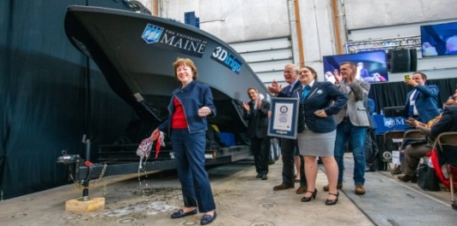
The Advanced Structures and Composites Center (ASCC) is a world-leading, interdisciplinary center for research, education, and economic development encompassing material sciences, engineering, and advanced manufacturing of composites and structures. Housed in a 100,000 ft² ISO-17025 accredited facility, the ASCC has been recognized nationally and internationally for cutting edge research programs leading and impacting new industries including offshore wind and marine energy, civil infrastructure, bio-based large-scale 3D printing, soldier protection systems, and innovative defense-related applications. The ASCC is the largest university-based research center in Maine, and one of the fastest growing research laboratories in the world, with research revenue growth of 5X in the past 5 years. The facility has expanded to include 13 integrated laboratories with more than 260 full and part time personnel, including faculty, staff, and students. Since its founding in 1996 with support from the National Science Foundation, the Center has financially sponsored more than 2,600 students, received 70 patents, received over 26,000 visitors, created 14 spinoff companies through licensing of patents or trade secrets, and received more than 40 national and global awards for research excellence.
3Dirigo, a 25 ft. long, 5,000 lbs patrol boat printed by UMaine in 72 hours, winning a Guinness World Record.

The ASCC’s 2020 Strategic Plan, called GEM, focuses the Center’s work on Green Energy and Materials development. Through GEM, the Center is at the forefront of major new sustainability industries in the U.S., including these recent successful initiatives:
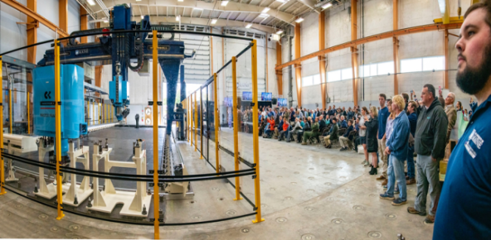
Largest polymer 3D printer in the world, commissioned at ASCC in Q4 2019. The print volume is 60 ft x 22 ft x 10 ft, and deposition rate is 150 lbs/hour.
- First large-scale bio-based additive manufacturing program in the US, via a $20M additive manufacturing program with Oak Ridge National Lab to work with the forest products industry to produce new bio-based materials that will be conducive to 3D printing large-scale products such as boat hull molds, shelters, building components, tooling for composites, and wind blades. Read more about this accomplishment
- Floating offshore wind technology developed at the ASCC led to a $100M investment by global energy heavyweights Diamond Offshore Wind and RWE Renewables, and $50M investment from the US DOE, to launch the first full-scale floating offshore wind project off the Maine coast. Read more about this accomplishment
ASCC received $150M commitment from private investors and the US DOE to build a 10-12 MW floating turbine using its patented VolturnUS technology.
- Awarded three Guinness World Records for the world’s largest prototype polymer 3D printer, largest solid 3D-printed object, and largest 3D-printed boat. The awards came after ASCC printed 3Dirigo, a 25-ft marine patrol vessel weighing 5,000 lbs in under 3 days. Read more about this accomplishment
- Selected to lead the $14.2M Transportation Infrastructure Durability Center with 5 other universities across New England to develop more sustainable, transformative, and economical solutions to address our nation’s infrastructure challenges. Read more about this accomplishment
Engage with world-leading experts and researchers
Access state-of-the-art equipment and facilities
Build your career as a PI/Co-PI
Live in beautiful Maine
Build a Meaningful and Successful Career in Research
PURPOSE: Supports a research program aimed at merging high performance computing (HPC) with large-area additive manufacturing (LAAM) of thermoplastic composite materials and structures. Research activities include development and evaluation of computational tools and methods that will support future realization of a process-informed, physics-based, and HPC-enabled computational framework for LAAM. Such a framework is expected to have the ability to (a) predict the post-fabrication properties and response characteristics of the printed product, (b) optimize the product and the process, and (c) facilitate in-situ monitoring and data feedback for process adjustments by incorporating machine learning and artificial intelligence (AI), thereby fulfilling the vision of digital thread / digital twin for additive manufacturing.
The Postdoctoral Research Associate will support, plan, and conduct assigned and original research encompassing computational modeling of LAAM based on the fused deposition process as well as integrated product-process design optimization informed by material-process-property models, while working collaboratively with faculty, staff, as well as graduate and undergraduate students at the Advanced Structures and Composites Center, and the Department of Mechanical Engineering.
ESSENTIAL DUTIES/RESPONSIBILITIES:
- Develop, implement, and evaluate computational models for advancing the understanding of large-scale fused deposition of thermoplastics and composites
- Perform computational simulations involving multi-scale models
- Integrate variable fidelity models for process and product performance simulations in an HPC environment
- Investigate alternative multilevel and multidisciplinary design optimization algorithms and strategies for LAAM
- Present and report research results and publish scientific results in peer-reviewed journals in a timely fashion
- Lead and participate in writing publications and patent applications
- Supervise and lead teams of research engineers, graduate students, and undergraduate students
- Ensure compliance with environmental, health, and safety requirements
- Adhere to and foster the ethical practice of science and engineering

TECHNICAL QUALIFICATIONS:
- PhD in Mechanical Engineering, Materials Science, or a related discipline completed within the last 5 years
- Prior coursework or research in additive manufacturing, composites, and solid mechanics
- Experience with nonlinear finite-element modeling of process-dependent solutions to thermo-mechanical problems using both commercial and research codes
- Broad knowledge of design optimization, reduced-order modeling, surrogate modeling / machine learning in the context of integrated computational materials engineering

GENERAL REQUIREMENTS
- Experience with finite element model creation and simulation
- Experience with parallel processing and high performance computing
- Experience with additive manufacturing, and particularly fused deposition modeling
- Experience with algorithms and strategies for design optimization of complex systems
- Experience with numerical modeling and solution of multi-physics problems, including the development and validation of user subroutines
- Experience designing and conducting experiments for the development and validation of numerical models
- An excellent record of productive and creative research as demonstrated by publications in peer-reviewed journals and conference proceedings
- Excellent written and oral communication skills
- Ability to work with and mentor others as well as set priorities to accomplish multiple tasks within deadlines
SUPERVISORY RESPONSIBILITIES: Undergraduate Research Assistants, Graduate Research Assistants, and Engineering Staff.

POSITION TYPE: Contingent on funding and successful performance. Overall maximum duration of Postdoctoral position is five years.

WORK SCHEDULE: Normal University of Maine business hours are Monday through Friday 8:00 a.m. to 4:30 p.m. Work outside of normal business hours will be necessary in order to complete the requirements of the position.

WORK ENVIRONMENT: Work will be performed at the Advanced Structures and Composites Center with over 230 faculty, staff and students conducting contract research with a variety of public and private entities as well as in the Department of Mechanical Engineering.

SCHEDULE FOR EVALUATION: In the initial six months of employment and annually thereafter in accordance with the UMPSA agreement.

Appropriate background checks and pre-employment physical will be required.

All UMS employees are required to comply with applicable policies and procedures, as well as to complete applicable workplace related screenings, and required employee trainings, such as Information Security, Safety Training, Workplace Violence and Sexual Harassment.

