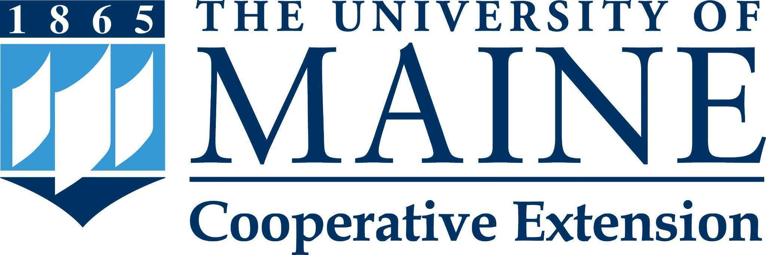

Putting knowledge to work with the people of Maine.

Position Title: Postdoctoral Extension Associate in PFAS Research and Outreach
Department: Cooperative Extension
Reports To: Program Administrator
Bargaining Unit: UMPSA
Position Type: Full-time, fiscal-year, fixed-length position.

Purpose:
The Postdoctoral Extension Associate in PFAS Research and Outreach with the University of Maine Cooperative Extension will join a collaborative PFAS team that includes UMaine Cooperative Extension and the Maine Agricultural and Forest Experiment Station focused on PFAS and Maine agriculture. The postdoctoral extension associate in this position will develop and lead research and educational outreach that directly addresses the short- and long-term needs of farmers and other agricultural stakeholders impacted by PFAS contamination including PFAS transport through agricultural systems and possible mitigation options. They will do so in collaboration with other faculty and staff in both Cooperative Extension and in the Maine Agricultural and Forest Experiment Station, state agencies, and stakeholder groups to help build statewide capacity in addressing PFAS contamination in agriculture.

Essential Duties & Responsibilities:
- Designs, implements, evaluates, and communicates to stakeholders a Plan-of-Work that aligns with the University of Maine Cooperative Extension mission and addresses PFAS contamination in agriculture. Areas of potential focus include: movement and transfer of PFAS in soils and plants, mitigation options for contaminated sites, and alternative crops and crop and management system to avoid contamination issues.
- Develops, coordinates, implements, and evaluates PFAS educational programming for agricultural audiences.
- Coordinates with state and federal agencies (Maine DACF, Maine DEP, Maine CDC and FDA) to assist with research and outreach activities to farmers and consumers.
- Seeks and acquires external funding to support research and outreach work; effectively manages ongoing grants, contracts, and special funds.
- Builds and sustains relationships and collaborates with colleagues in Cooperative Extension, faculty and staff from other UMaine academic departments, and faculty and staff throughout the UMaine System and community partners.
- Partners with faculty and staff to disseminate the results of research and other scholarly work.
- Provide timely and accurate information in response to public requests for information.
- Communicates outcomes, impacts, and public values to a variety of audiences (including legislators, funders, consumers, and other decision makers).
- Compile and submit reports as requested or required (Civil Rights, Program Impact, and Plan-of-Work).
- Seeks ways to reach under-served and under-represented community members while ensuring compliance with affirmative action, equal opportunity, and civil rights guidelines.
- Hires, trains, and supervises professionals, hourly, and/or student employees as appropriate, including conducting or participating in required performance evaluations, and providing safety and environmental management oversight.
- Develops and maintains professional relationships that reflect courtesy, civility, and mutual respect.
- Commits to organizational improvement by identifying opportunities to improve and recommending possible alternatives.
- Performs other reasonably related duties as assigned.

Knowledge, Skills & Qualifications:
Required:
- Ph.D as appropriate in plant, soil or environmental science by date of hire.
- Knowledge of current and emerging issues, practices, and trends in the relevant field.
- Proven ability to achieve goals and manage multiple tasks.
- Documented record of conducting high-quality, applied scientific research, demonstrated by publication in peer-reviewed journals, Extension-type fact sheets, and popular press.
- Excellent interpersonal, technical writing, and public communication skills.
- Experience in a variety of delivery methods to disseminate research-based information.
- Proficiency with word processing, data management, and statistical computer programs such as Microsoft Excel, Word and PowerPoint, as well as Google Drive and document management software.
- Ability to work both independently and effectively with others in a team environment.
- Valid driver’s license (at least 2 years).
- Ability to lift 40 lbs.

Preferred:
- Experience with Cooperative Extension educational program development, delivery and evaluation.
- Demonstrated experience with community needs assessments.
- Experience in grant writing and the financial management of grant funds.
- Experience working with diverse audiences; knowledge of diversity, equity and inclusion; and understanding of equal opportunity, affirmative action and civil rights policies.
- Successful supervisory experience.

Supervisory Responsibilities: No supervisory responsibilities are required at time of hire. The supervision of professional, temporary classified staff, and student workers, including supervision of day to day activities, project oversight, and conducting performance evaluations, may be assigned in the future.

Work Environment / Dynamics: The individual in this position will work statewide, with their office location at the University of Maine campus in Orono (ME). Hybrid work arrangements may be possible with the approval from supervisor and upper level administrators.

Work Year: Full-time, 12-month fiscal year position.

Work Schedule: Normal University of Maine Cooperative Extension office hours are Monday through Friday, 8:00 a.m. to 4:30 p.m. Schedule adjustments, including some evening and occasional weekend work throughout the state, will be necessary to meet the needs of the program and its clients.

Schedule for Evaluation: Performance evaluations will be conducted in accordance with the University of Maine System (UMS) and the University of Maine Professional Staff Association (UMPSA) collective bargaining agreement. An annual Plan of Work will serve as the framework for performance evaluation with flexibility for change, for example, unanticipated audience needs.

To Apply:
To apply, materials must be submitted via "Apply For Position". The applicant will need to create a profile and application; upload a letter of intent (cover letter) addressing the specific job requirements, updated curriculum vitae, and contact information for three (3) current professional references (names, addresses, phone numbers, e-mail addresses, and relationship to applicant) that may be contacted. The applicant will also need to complete the affirmative action survey, the self-identification of disability form, and the self-identification of veteran status form. Incomplete application materials cannot be considered.
All UMS employees are required to comply with applicable policies and procedures, as well as to complete applicable workplace related screenings, and required employee trainings, such as Information Security, Safety Training, Workplace Violence, and Sexual Harassment. Appropriate background checks are required.
The University of Maine is an EEO/AA Employer. All qualified applicants will receive consideration for employment without regard to race, color, religion, sex, national origin, sexual orientation, age, disability, protected veteran status, or any other characteristic protected by law.

