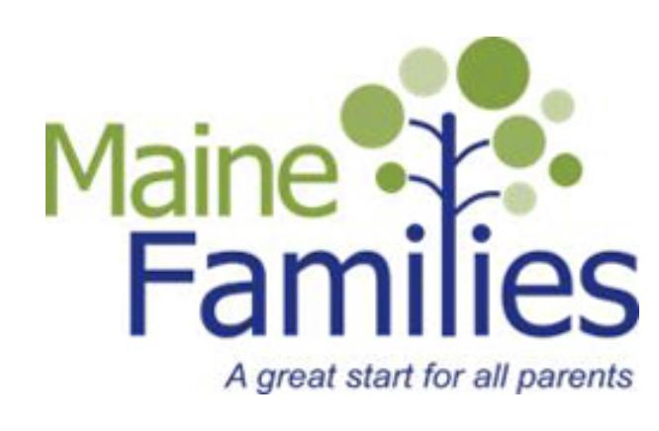

Putting knowledge to work with the people of Maine.

Position Title: Parent Education Professional / Maine Families Visitor
Rank: Professional I
Dept: Cooperative Extension
Reports to: Program Supervisor
Position Type: Full-time 40 hours per week, fiscal year, professional position contingent on funding and successful job performance

Purpose:

Through University of Maine Cooperative Extension’s Maine Families Program, the Parent Education Professional delivers the Parent as Teachers™ evidence-based home visiting model to affect real change for families. This model is based on respected research findings with numerous studies demonstrating the following positive outcomes: increased parent knowledge of development, early detection of developmental delays, increased school readiness and prevention of child abuse and neglect as a basis. Parent Education Professionals also build protective factors that serve as buffers to reduce risk to young children, prenatal to age three, and families. These protective factors include parental resilience, knowledge of child development and parenting skills, social connections, and social-emotional competence of children. This model is designed to be delivered in the homes of parents or virtually through Zoom. This position works with families in Cumberland County in the towns of Falmouth, Cumberland, Yarmouth, Freeport, Brunswick, Harpswell, and Topsham as assigned.

Essential Duties and Responsibilities:
- Contact assigned families (referrals) in a timely manner and initiate face-to-face contact with parent(s) to explain the program with the goal of enrolling parents prenatally.
- Partner with parents to determine the level of interaction (number of visits per month).
- Provide a minimum of 325 home visits (in person or virtual visits) a year to enrolled families.
- Design creative approaches to outreach.
- Assess and provide appropriate education, support and advocacy skills to assist parents in being their child's first most effective teacher(s).
- Deliver the Parents as Teachers™ curriculum using appropriate assessments and create follow-up/referral support.
- Provide accurate, timely and complete reports of work with each family that will show measurable outcomes or progress as required by the current year's grantor by using the tools required by the current grant. This includes electronic records.
- Attend weekly supervision and staff meetings as well as monthly clinical meetings.
- Maintain knowledge of current parenting/child development issues by attending required 20 hours professional development training annually.
- Help organize, attend, facilitate and document Parents as Teachers group connections.
- Maintain effective relationships with individuals and organizations/agencies that make referrals or provide services to families.
- Work with interpreters and cultural brokers to provide services to families.
- Seek ways to reach under-served and under-represented audiences while ensuring compliance with affirmative action, equal opportunity and civil rights requirements.
- Develop and maintain professional relationships that reflect courtesy, civility, and mutual respect.
- Adhere to the guidelines and requirements of the current Maine Families contract as outlined in the current Standards of Practice and Policies and Procedures.
- Perform other reasonably related duties.

Knowledge/Skill Qualifications

Required:
- Bachelor’s degree in child development, early education, social work, or related field and a minimum of one year paid experience working with children birth to age 6.
- Exemplary communication skills; effectively using oral, auditory, written and electronic methods.
- Demonstrated skills in engaging parents in being their child’s first teacher.
- Demonstrated skills in establishing rapport and assessing the needs of parents and young children, prenatal to age three.
- Proven skills in delivering parent education regarding developing positive parenting skills, providing intricate knowledge of child development and strengthening complex parent-child relationships.
- Demonstrated skills in maintaining confidentiality.
- Accuracy and completeness in keeping electronic data/records of work with each family to meet the obligations of current grant.
- Ability to work independently and manage multiple tasks in an autonomous work environment as well work effectively as part of a team, and able to achieve and document measurable results.
- Ability to acquire and maintain yearly renewal of Parents as Teachers & Maine Roads to Quality certificates.
- Ability to travel with personal vehicle (travel reimbursed at the current grant rate) usually requiring valid driver’s license.
- Demonstrated computer skills including word processing in Microsoft Word and basic e-mail skills. Ability to process personal correspondence.

Preferred:
- Experience in referring families by having up-to-date knowledge of other local agencies and organizations serving families.
- Experience serving families from diverse cultural backgrounds.
- Participate in County UMaine Extension staff and Extension Association meetings and events as appropriate.
- Knowledge of University of Maine Cooperative Extension and its educational programs.
- Proficiency with computer programs such as Microsoft Excel, Word and PowerPoint, as well as Google Drive and document management software.
- Experience working with diverse audiences; knowledge of diversity, equity and inclusion; and understanding of equal opportunity, affirmative action and civil rights policies.

Supervisory Responsibilities: None

Work Environment: The Parent Education Professional will work remotely and in the field with a homebase in the Knox Lincoln County Extension Office at 377 Manktown Road, Waldoboro. Travel within Cumberland County is required.

Work Schedule: Typical UMaine Extension hours are from 8:00 a.m. to 4:30 p.m. Monday through Friday. This position requires a work schedule with some evening and weekend work. The employee will establish regular office hours in consultation with their Program Manager/Supervisor and be accountable in a daily (Google) calendar. This individual will adjust her work schedule in order to meet the needs of families and requirements of the position.

Performance Evaluation: Universities of Maine Professional Staff Association (UMPSA). In the initial six months of employment then annually thereafter in accordance with the UMS-UMPSA Agreement.

To Apply:
To apply, materials must be submitted via "Apply For Position". The applicant will need to create a profile and application; upload a letter of intent (cover letter) addressing the specific job requirements, updated curriculum vitae, and contact information for three (3) current professional references (names, addresses, phone numbers, e-mail addresses, and relationship to applicant) that may be contacted. The applicant will also need to complete the affirmative action survey, the self-identification of disability form, and the self-identification of veteran status form. Incomplete application materials cannot be considered.
All UMS employees are required to comply with applicable policies and procedures, as well as to complete applicable workplace related screenings, and required employee trainings, such as Information Security, Safety Training, Workplace Violence, and Sexual Harassment. Appropriate background checks are required.
The University of Maine is an EEO/AA Employer. All qualified applicants will receive consideration for employment without regard to race, color, religion, sex, national origin, sexual orientation, age, disability, protected veteran status, or any other characteristic protected by law.

