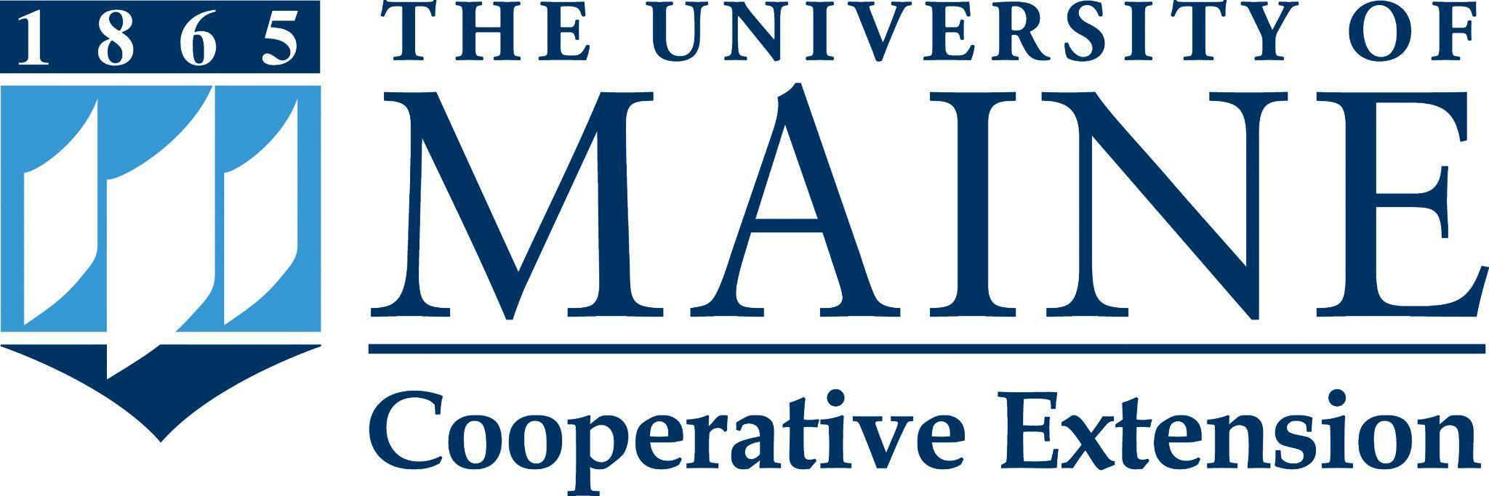

Putting knowledge to work with the people of Maine.

Position Title: Veterinarian and Assistant Extension Professor
Department: Cooperative Extension
Reports To: Program Administrator
Bargaining Unit: Associated Faculties of the University of Maine system (AFUM)
Position Type: Full-time, fiscal year, base budgeted

Purpose
The Veterinarian and Assistant Extension Professor faculty position is a 100% Cooperative Extension appointment. This position is responsible for the direction and oversight of the activities of the University of Maine Cooperative Extension Veterinary Diagnostic Laboratory and provides Extension education. The faculty member will develop and conduct educational programs throughout the State of Maine in animal health. This position is expected to work in partnership with other University faculty, state and federal agencies and practicing veterinarians in addressing high priority animal disease issues through both educational programs and applied research. The faculty member is required to show proof of having passed the United States National Veterinary Board Examinations and is expected to acquire a Maine Veterinary License within one year of the date of hire.

Essential Duties & Responsibilities
Extension:
- Set priorities and direction for the activities of the Veterinary Diagnostic Laboratory. This includes performing necropsies, relevant lab work and supervising case management and providing written reports to clients. Must become Board Certified Pathologist within 3 years of hire.
- Work collaboratively with Extension faculty, practicing veterinarians, livestock producers and others to provide educational support regarding animal diseases, promoting farm risk management education and disease prevention.
- Work collaboratively with staff of State and Federal agencies; practicing veterinarians and others in the education of Maine farmers and citizens regarding foreign animal diseases, zoonotic diseases and programs such as the Maine Cattle Health Assurance Program (MeCHAP) and working with wildlife species in collaboration with Maine Inland Fisheries and Wildlife.
- Conduct an educational needs assessment to serve as the basis for a Plan of Work that will guide the activities of this position. The assessment will involve program partners, agricultural producers, faculty and others.
- Develop, conduct, evaluate and report on educational programs for agricultural producers, citizens, professionals, and co-workers on animal health management.
- Develop and manage an annual budget for the Veterinary Disease Diagnostic Laboratory that includes revenue generation with the goal of fully supporting its activities.
- Understand and follow SOPs for the Cooperative Extension Diagnostic and Research Laboratories, including the high biosafety level labs, and work collaboratively with other managers within to maintain security.
- Maintain the Veterinary Diagnostic Laboratory facility and equipment. Work closely with extension and academic faculty in addressing animal health education as part of a multidisciplinary team.
- Compile reports as requested, such as Civil Rights, Program Impact, and Plan-of-Work. Provide timely and accurate information in response to public requests for information.
- Work to involve and serve under-represented clients, according to civil rights laws and objectives.
- Hires, trains, and supervises professionals, hourly, and/or student employees as appropriate, including conducting or participating in required performance evaluations, and providing safety and environmental management oversight.
- Utilizes coaching and mentoring methods, which provide an environment that is anticipatory, supportive, and encourages constructive feedback on performance.
- Develops and maintains professional relationships that reflect courtesy, civility, and mutual respect.
- Commits to organizational improvement by identifying opportunities to improve and recommending possible alternatives.
- Performs other reasonably related duties as assigned.

Research:
- Develop and conduct an applied research program that addresses the priority animal health needs of Maine food animal producers. This includes the publication of research findings in peer reviewed journals.
- Seek and acquire external funding to support educational programming, applied research and scholarly work. This work requires assuming the principal investigator role for projects currently funded or being reviewed for funding. The faculty member will manage grants and contracts and special funds.

Supervisory Responsibility:
- Supervise the professional lab staff. Supervision of other professional and classified staff may be required, including conducting all required performance evaluations.

Knowledge, Skills & Qualifications
Required:
- Doctorate of veterinary medicine (DVM or equivalent degree).
- Eligibility for veterinary licensure in the State of Maine.
- Demonstrated ability to perform and financially support terrestrial animal research through the successful acquisition of external funding.
- Ability to communicate effectively using oral, written, and electronic methods.
- Demonstrated positive interpersonal skills for working with coworkers, employer, and constituents from the community.
- Ability to work independently as well as part of a team; must be self-motivated and directed with the ability to achieve measurable results.
- Computer and educational technology skills.
- Ability to travel, normally requiring a driver's license.

Preferred:
- Board certified veterinarian or eligible for certification within the first year.
- Board certified pathologist or post-graduate training/ experience in pathology.
- Experience serving diverse audiences and working with equal opportunity, affirmative action and civil rights policies.
- Experience with Extension educational program development, implementation, and evaluation or other educational outreach activities.
- Demonstrated successful supervisory experience.
- Experience with development and management of an annual budget that includes revenue generation with the goal of fully supporting its activities.
- Experience with high biosafety level labs (BSL3)
- Work collaboratively with other managers within to maintain security

Supervisory Responsibilities: The supervision of professional, temporary classified staff, and student workers, including supervision of day to day activities, project oversight, and conducting performance evaluations, may be assigned in the future.

Work Environment / Dynamics: Position will be housed in the University of Maine Cooperative Extension Diagnostic and Research Laboratory in Orono. The position will have an office with access to support staff. Computer hardware and software is provided.

Work Schedule: Normal University of Maine Cooperative Extension office hours are Monday through Friday, 8:00 a.m. to 4:30 p.m. Work beyond regular business hours (to include nights and weekends) will be necessary to meet the needs of the position and clients served. The incumbent will adjust the work schedule as necessary in consultation with the supervisor.

Schedule for Evaluation: Performance evaluations will be conducted in accordance with the University of Maine System (UMS) and the Associated Faculties of the UMS (AFUM) collective bargaining agreement. An annual Plan of Work will serve as the framework for performance evaluation with flexibility for change, for example, unanticipated audience needs.

To Apply:
To apply, materials must be submitted via "Apply For Position". The applicant will need to create a profile and application; upload a letter of intent (cover letter) addressing the specific job requirements, updated curriculum vitae, and contact information for three (3) current professional references (names, addresses, phone numbers, e-mail addresses, and relationship to applicant) that may be contacted. The applicant will also need to complete the affirmative action survey, the self-identification of disability form, and the self-identification of veteran status form. Incomplete application materials cannot be considered.
All UMS employees are required to comply with applicable policies and procedures, as well as to complete applicable workplace related screenings, and required employee trainings, such as Information Security, Safety Training, Workplace Violence, and Sexual Harassment. Appropriate background checks are required.
The University of Maine is an EEO/AA institution and does not discriminate on the grounds of race, color, religion, sex, sexual orientation, transgender status, gender expression, national origin, citizenship status, age, disability, genetic information or veteran’s status in employment, education, and all other programs and activities. The following person has been designated to handle inquiries regarding non-discrimination policies: Director of Equal Opportunity, 101 Boudreau Hall, University of Maine, Orono, ME 04469-5754, 207.581.1226, TTY 711 (Maine Relay System).

