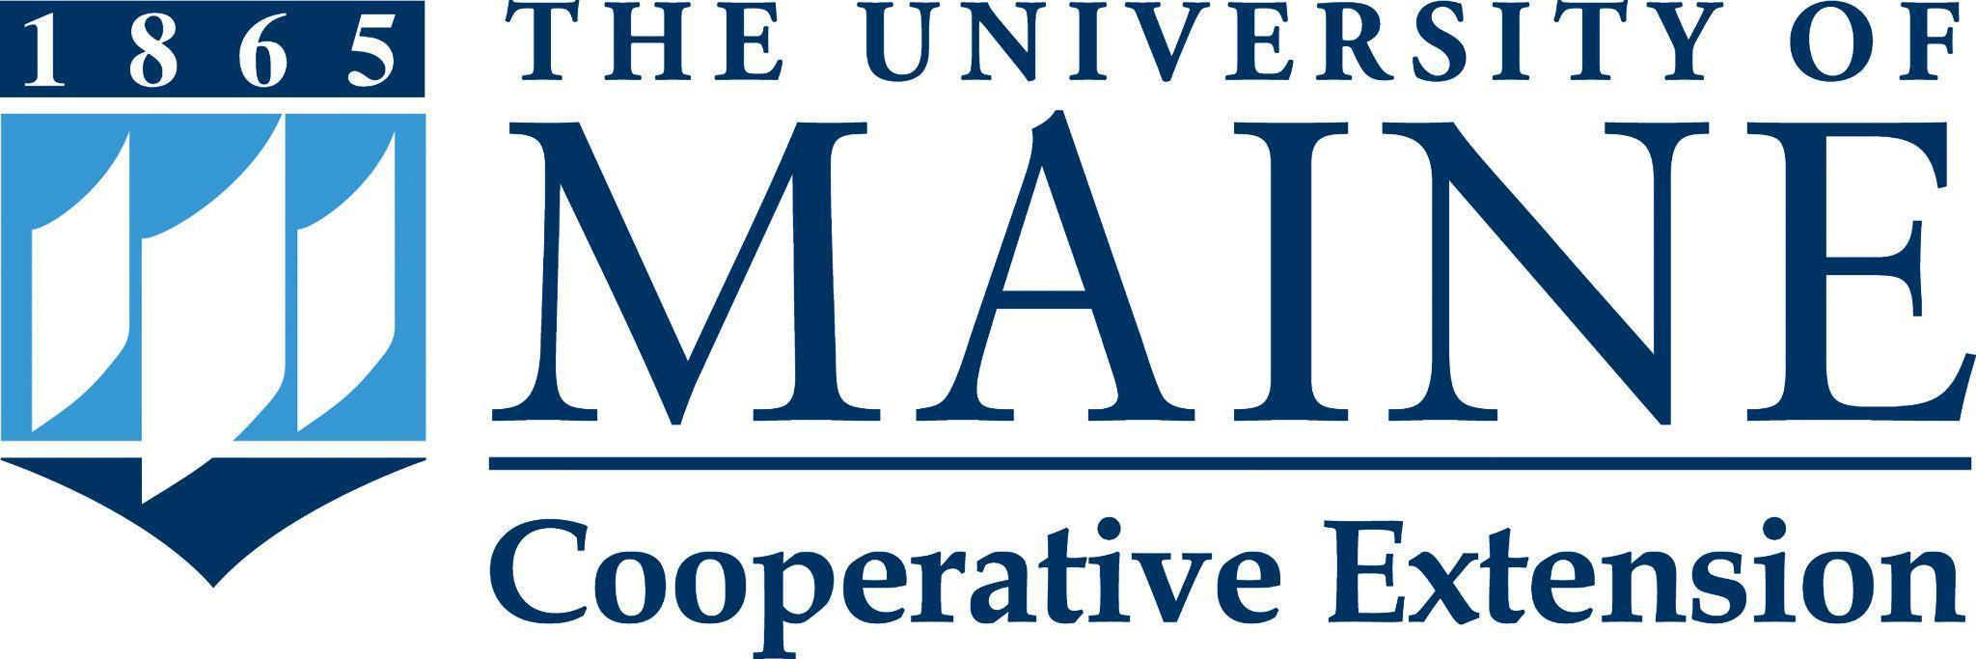

Putting knowledge to work with the people of Maine.

Position Title: Assistant/Associate Extension Professor, Seafood Technology and Food Safety Specialist
Department: Cooperative Extension
Reports To: Program Administrator
Bargaining Unit: Associated Faculties of the University of Maine system (AFUM)
Position Type: Full-time, fiscal year, continuing contract eligible faculty position

Purpose:
The Assistant/Associate Extension Professor and Seafood technology and Food Safety Specialist
with the University of Maine Cooperative Extension will directly support the over $2.5 billion Maine Seafood / Aquaculture Industries by providing impactful federally- and state-required food safety workforce training, education, and research. The position will also support the development of new seafood products, processes, and training to support the workforce. The faculty member in this position will provide leadership for Cooperative Extension’s seafood technology and food safety programming and applied research. The faculty member, in partnership with county and campus-based Extension staff and UMaine faculty, will develop or assist educational programing and applied research focused on seafood and food safety. The position will address the wide spectrum of seafood and aquaculture industry food safety and processing needs with a priority for the needs of Maine small businesses. The position will conduct applied research and scholarship in collaboration with colleagues within Cooperative Extension, Aquaculture Research Institute (ARI), the UMaine School of Food and Agriculture, and others.

Essential Duties & Responsibilities:
- Design, implement, evaluate, and communicate to stakeholders a Plan of Work that aligns with the University of Maine Cooperative Extension mission and addresses high priority food safety needs of small businesses and consumers
- Collaborate closely with the University of Maine Aquaculture Institute (ARI) Research Team.
- Build and sustain linkages and collaborate with colleagues in Cooperative Extension, ARI, Maine Sea Grant, School of Food and Agriculture, and other relevant academic units on issues related to seafood technology and food safety.
- Work in partnership with the Extension faculty and staff, county and campus-based colleagues, and statewide partners to:
  - Develop and conduct educational programs for stakeholders, Cooperative Extension staff and other professionals, work independently and as part of teams, on issues related to seafood technology and food safety
  - Serve as a resource for timely and relevant seafood technology and food safety information for faculty, professional and classified staff within Cooperative Extension, and for statewide agency professionals
- Serve in a leadership role for the seafood technology and food safety network within Cooperative Extension
- Build and sustain linkages and collaborate with colleagues in Cooperative Extension, ARI, Maine Sea Grant and other relevant academic units on issues related to seafood technology and food safety.
- Provide food safety education/information to commercial food businesses where relevant including Seafood HACCP (Hazard Analysis Critical Control Point) certification workshops and commercial sanitation.
- Develop a network of Maine seafood processors to provide the latest food safety education and encourage information and resource sharing.
- Work as part of a team with external agencies and organizations to address multi-county, state, multi-state and national issues related to food safety
- Develop online programming to support the needs of the aquaculture and seafood industry sectors.
- Teach courses for credit (including micro-credentials) for enrolled university students, community members seeking certification, and/or others.
- Disseminate the results of applied research and other scholarly work
- Participate in local, regional and state program development teams
- Ensure compliance with civil rights, affirmative action, and equal opportunity
- Hire, orient and supervise professionals, classified, and/or student employees as appropriate, including conducting or participating in required performance evaluations, and providing safety and environmental management oversight
- Utilize coaching and mentoring methods, which provide an environment that is anticipatory, supportive, and encourages constructive feedback on performance
- Develop and maintain professional relationships that reflect courtesy, civility, and mutual respect
- Develop and sustain a professional development plan in support of one’s Plan of Work
- Contribute to University of Maine Cooperative Extension’s overall marketing initiatives as part of one’s Plan of Work
- Commit to organizational improvement by identifying opportunities to improve and recommending possible alternatives
- Perform other reasonably related duties as assigned

Knowledge, Skills & Qualifications:
Required:
- Earned Ph.D in Food Science or closely related field
- Experience with food safety procedures including seafood HACCP and sanitation
- Demonstrated ability to design, deliver and evaluate educational programs
- Knowledge of, or documented record of, conducting high-quality, applied scientific research, demonstrated by publication in peer-reviewed journals and/or popular press
- Demonstrated computer and educational technology skills
- Excellent interpersonal, technical writing, and public communication skills
- Knowledge of or experience in grant writing
- Demonstrated ability to work well as part of a team and independently; must be self-motivated and directed with the ability to achieve goals and manage multiple tasks in an autonomous work environment
- Ability to travel, usually requiring a valid driver’s license, both in- and out-of-state, with reimbursement at the contract rate
- Ability to work a flexible schedule, depending upon the needs of interested parties

Preferred:
- Experience with Cooperative Extension educational program development, delivery and evaluation
- Familiarity with aquaculture practices, regulations, and research, with a focus on Maine's aquaculture industry
- Established record of effectiveness in Extension educational programming
- Demonstrated experience with applied research and community needs assessments
- Experience in grant writing and the financial management of grant funds
- Successful supervisory experience
- Experience working with diverse audiences; knowledge of diversity, equity and inclusion; and understanding of equal opportunity, affirmative action and civil rights policies

Supervisory Responsibilities: Supervision of professional, temporary classified staff, and student workers, including supervision of day-to-day activities, project oversight, and conducting performance evaluations.

Work Environment / Dynamics: This position will be based primarily on the University of Maine, Orono, campus, in an office in Hitchner Hall. Frequent travel throughout the county, and some state and regional travel is expected.

Work Schedule: Normal University of Maine Cooperative Extension office hours are Monday through Friday, 8:00 a.m. to 4:30 p.m. Schedule adjustments, including some evening and occasional weekend work throughout the state, will be necessary to meet the needs of the program and its clients.

Schedule for Evaluation: Performance evaluations will be conducted in accordance with the University of Maine System (UMS) and the Associated Faculties of the UMS (AFUM) collective bargaining agreement. An annual Plan of Work will serve as the framework for performance evaluation with flexibility for change, for example, unanticipated audience needs.

To Apply:
To apply, materials must be submitted via "Apply For Position". The applicant will need to create a profile and application; upload a letter of intent (cover letter) addressing the specific job requirements, updated curriculum vitae, and contact information for three (3) current professional references (names, addresses, phone numbers, e-mail addresses, and relationship to applicant) that may be contacted. The applicant will also need to complete the affirmative action survey, the self-identification of disability form, and the self-identification of veteran status form. Incomplete application materials cannot be considered.
All UMS employees are required to comply with applicable policies and procedures, as well as to complete applicable workplace related screenings, and required employee trainings, such as Information Security, Safety Training, Workplace Violence, and Sexual Harassment. Appropriate background checks are required.
In complying with the letter and spirit of applicable laws and pursuing its own goals of diversity, the University of Maine System does not discriminate on the grounds of race, color, religion, sex, sexual orientation, transgender status, gender, gender identity or expression, ethnicity, national origin, citizenship status, familial status, ancestry, age, disability physical or mental, genetic information, or veterans or military status in employment, education, and all other programs and activities. The University provides reasonable accommodations to qualified individuals with disabilities upon request. The following person has been designated to handle inquiries regarding non-discrimination policies: Director of Equal Opportunity, 5713 Chadbourne Hall, Room 412, University of Maine, Orono, ME 04469-5754, 207.581.1226, TTY 711 (Maine Relay System).

