University of Maine
Job Description

Title: Fiscal and Administrative Coordinator
Unit: Advanced Structures and Composites Center
Date: May 2022
Reports to: Senior Grants and Contracts Administrator

Introduction to the Advanced Structures and Composites Center
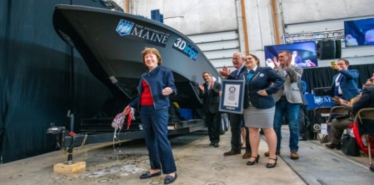
The Advanced Structures and Composites Center (ASCC) is a world-leading, interdisciplinary center for research, education, and economic development encompassing material sciences, advanced manufacturing and engineering of composites and structures. Housed in a 100,000ft² ISO-17025 accredited facility, the ASCC has been recognized nationally and internationally for cutting edge research programs leading and impacting new industries including offshore wind and marine energy, civil infrastructure, bio-based large-scale 3D printing, soldier protection systems and innovative defense-related applications. The ASCC is the largest university-based research Center in Maine, and one of the fastest growing research laboratories in the world, with research revenue growth of 5X in the past 5 years. Facility has expanded to include 13 integrated laboratories with more than 260 full and part time personnel, including faculty, staff and students. Since its founding in 1996 with support from the National Science Foundation, the Center has financially sponsored more than 2,600 students, received 70 patents, received over 26,000 visitors, created 14 spinoff companies through licensing of patents or trade secrets, and received more than 40 national and global awards for research excellence.
3Dirigo, a 25 ft. long, 5,000lbs patrol boat printed by UMaine in 72 hours, winning a Guinness World Record.

The ASCC’s 2020 Strategic Plan, called GEM, focuses the Center’s work on Green Energy and Materials development. Through GEM, the Center is at the forefront of major new sustainability industries in the U.S., including these recent successful initiatives:
ASCC received $150 million commitment from private investors and the US DOE to build a 10-12MW floating turbine using its patented VolturnUS technology.

- Floating offshore wind technology developed at the ASCC led to a $100 million investment by global energy heavyweights Diamond Offshore Wind and RWE Renewables, and $50 million investment from the US DOE, to launch the first full-scale floating offshore wind project off the Maine coast. Read more about this accomplishment
- Awarded three Guinness World Records for the world’s largest prototype polymer 3D printer, largest solid 3D-printed object, and largest 3D-printed boat. The awards came after ASCC printed 3Dirigo, a 25ft marine patrol vessel weighing 5,000lbs in under 3 days. Read more about this accomplishment
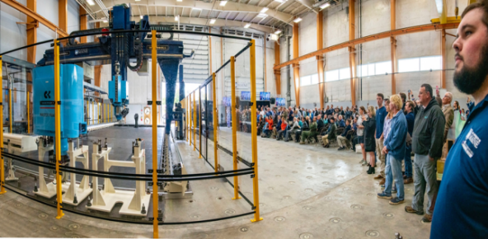
- First large-scale bio-based additive manufacturing program in the US, via a $20M additive manufacturing program with Oak Ridge National Lab to work with the forest products industry to produce new bio-based materials that will be conducive to 3D printing large-scale products such as boat hull molds, shelters, building components, tooling for composites and wind blades. Read more about this accomplishment
Largest polymer 3D printer in the world, commissioned at ASCC in Q4 2019. The print volume is 60 ft x 22ft x 10ft, and deposition rate is 150 lbs/hour
- Selected to lead the $14.2 million Transportation Infrastructure Durability Center with 5 other universities across New England to develop more sustainable, transformative and economical solutions to address our nation’s infrastructure challenges. Read more about this accomplishment

Purpose of Position: To facilitate and enhance research related financial and administration activities at the University of Maine, Advanced Structures and Composites Center.
Essential Functions and Responsibilities:
- Works within an assigned technical team dynamic to offer fiscal coordination services that are integral to program planning and development. This work may include actively engaging with external stakeholders to gather and develop cost share and subaward materials in repeatable templates, such as Letters of Commitment and Non-Disclosure Agreements.
- Analyzes financial records, prepares financial reports, supports annual budget creation and setup of the General Ledger, and interacts with ASCC’s fiscal and grants team members on matters involving budget setup and oversight.
- Facilitates services contracts with domestic and international service providers.
- Coordinates events and meetings.
- Adds new chartfield combinations to the system.
- Implements and maintains financial databases specific to UMaine research units.
- Audits accounts at a Work Breakdown Structure (WBS) or sub task level for discrepancies and works with Fiscal Lead to resolve errors.
- Designs and generates a variety of complex, financial performance reports.
- Assists with account reconciliation and summary reporting.
- Assists with year-end accounting and reporting procedures, including invoicing and closeout.
- Performs a full range of communications, both verbal and written, regarding non-routine questions, issues and procedures; handles the most complex and sensitive customer/student requests requiring a comprehensive understanding of relevant policies, procedures and rules; prepares individualized responses for non-routine and/or escalated issues.
- Researches, sorts and summarizes a variety of non-routine data for a broad range of applications and assignments; makes recommendations regarding the validity and quality of available data; prepares standard and non-standard summaries of relevant information.
- May manage human resource transactions and records and coordinates processing of personnel actions, including confidential information.
- Administers fiscal projects as assigned by the Senior Grants and Contracts administrator & ASCC and/or clients within the University of Maine System.
- Position supports ASCC Ocean/Offshore Project Management Team for assigned strategic initiatives.
- Other duties as reasonably assigned.
Knowledge and Skill Qualifications
Required:
- Experience with financial account management, business or related area.
- Excellent written and verbal communication skills.
- Experience with office and data management software including PowerPoint, Excel, and Word.
- Ability to work creatively and independently within a team environment, and to manage multiple projects and deadlines.
- Demonstrated ability to handle sensitive and confidential information.
- Ability to travel normally requiring a valid driver’s license.

Preferred:
- BS degree in business, finance or accounting.
- 1-3 years of related experience.
- Experience with PeopleSoft.
- Experience with Microsoft Visio and Microsoft Project.
- Macro programming experience with Excel.
- Experience with Smartsheets.
- Knowledge of federal, state, and/or community funding sources and mechanisms.
- Knowledge of current developments/trends in area of expertise.
- Familiarity with grant funding policies and procedures and applicable local, state, federal and university regulations.
Supervision Responsibilities: Position may supervise undergraduate students.
Schedule for Evaluation: In the initial six months of employment and annually thereafter in accordance with UMPSA agreement.
Work Environment: Work will be performed at the Advanced Structures and Composites Center 100,000 ft2 laboratory with a world-leading team of over 150 faculty, staff and students who conduct contract research with a variety of public and private entities developing the next generation of low-cost, high performance composite materials.
Work Schedule: Normal University of Maine business hours are Monday through Friday 8:00 a.m. to 4:30 p.m. Work outside of regular business hours (to include nights and weekends) will be necessary at times in order to meet the requirements of the position. In consultation with the supervisor the employee will establish regular office hours and adjust work schedule as necessary. This position is considered Essential Personnel in the ASCC Storm Day Policy.
Position Type: Contingent on funding and successful performance.
Job Family/Salary Band: 09/02.
Appropriate background checks will be required.
All UMS employees are required to comply with applicable policies and procedures, as well as to complete applicable workplace related screenings, and required employee trainings, such as Information Security, Safety Training, Workplace Violence, and Sexual Harassment.

