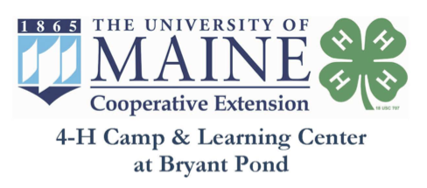

Food Services Technician
The kitchen staff at Bryant Pond 4-H Camp Center works closely with the directors to ensure the dietary needs of everyone at camp are met. The Food Services Supervisor will work with the camp director in ordering food, creating schedules, and making sure the kitchen is kept at Maine State health code standards. This position is part-time seasonal (April- Mid November) and is located in Bryant Pond, Maine.
The 4-H Camps at Bryant Pond provide environmentally-focused programs for Maine youth and families. Our mission is to teach youth and adults to be effective and caring citizens of the earth through affordable environmental education and fun nature-based experiences. For the 2023 program season, the Food Services Supervisor will prepare 2-3 meals per day for up to 120 people.

Responsibilities:
- Prepare and cook healthy meals and snacks for the camp, using whole foods and fresh produce.
- Safely operate commercial cooking equipment: mixer, slicer, dishwasher, and stoves; know when machines and knives need repair and specialized cleaning.
- Work as part of a team with other cooks and kitchen assistants in all aspects of food service operations
- Maintain safe food preparation, serving, and clean-up.
- Maintain a clean and sanitary kitchen facility in compliance with State of Maine standards and regulations.
- Work with food service supervisor in menu planning, food ordering, and preparing meals.
- Utilize produce from the camp’s garden.
- Pack up of food after each meal and help clean the kitchen so it is ready for the next meal to begin.
- Follow established protocols for the camp composting program.

Qualifications:
- Prior experience cooking nutritious and wholesome foods for large groups in a commercial kitchen
- Understanding of food allergies/dietary restrictions and how to safely accommodate them
- High safety and sanitation standards, current Serve Safe Food Safety Certification
- Attention to detail
- Ability to work a demanding schedule
- Flexible, team player
- Training and/or experience in sanitation, food preparation and protection, hygiene, and record-keeping

Compensation:
- Part-time, 30-40 hours per week
- $18.30 - $19.90/hour per hour (pre-tax) depending on experience
- Benefits include: meals during programming

In complying with the letter and spirit of applicable laws and pursuing its own goals of diversity, the University of Maine System does not discriminate on the grounds of race, color, religion, sex, sexual orientation, transgender status, gender, gender identity or expression, ethnicity, national origin, citizenship status, familial status, ancestry, age, disability physical or mental, genetic information, or veterans or military status in employment, education, and all other programs and activities. The University provides reasonable accommodations to qualified individuals with disabilities upon request. The following person has been designated to handle inquiries regarding non-discrimination policies: Director of Equal Opportunity, 101 Boudreau Hall, University of Maine, Orono, ME 04469-5754, 207.581.1226, TTY 711 (Maine Relay System).

