University of Maine
Job Description

TITLE: Engineer IV -Research Textile Manager
DEPARTMENT: Advanced Structures & Composites Center
DATE: November 30, 2023
REPORTS TO: Engineer VII – Technical Fellow

Introduction to the Advanced Structures and Composites Center
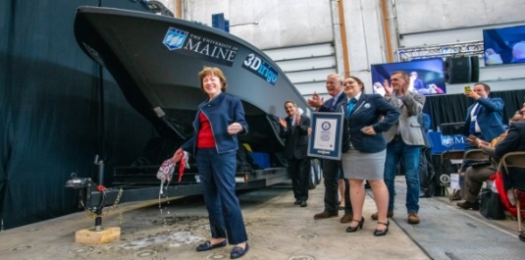
The Advanced Structures and Composites Center (ASCC) is a world-leading, interdisciplinary center for research, education, and economic development encompassing material sciences, advanced manufacturing and engineering of composites and structures. Housed in a 100,000ft² ISO-17025 accredited facility, the ASCC has been recognized nationally and internationally for cutting edge research programs leading and impacting new industries including offshore wind and marine energy, civil infrastructure, bio-based large-scale 3D printing, soldier protection systems and innovative defense-related applications. The ASCC is the largest university-based research Center in Maine, and one of the fastest growing research laboratories in the world, with research revenue growth of 5X in the past 5 years. Facility has expanded to include 13 integrated laboratories with more than 260 full and part time personnel, including faculty, staff, and students. Since its founding in 1996 with support from the National Science Foundation, the Center has financially sponsored more than 2,600 students, received 70 patents, received over 26,000 visitors, created 14 spinoff companies through licensing of patents or trade secrets, and received more than 40 national and global awards for research excellence.
3Dirigo, a 25 ft. long, 5,000lbs patrol boat printed by UMaine in 72 hours, winning a Guinness World Record.
ASCC secured $150 million commitment to build a 10-12MW floating turbine using its patented VolturnUS technology.

The ASCC’s 2020 Strategic Plan, called GEM, focuses the Center’s work on Green Energy and Materials development. Through GEM, the Center is at the forefront of major new sustainability industries in the U.S., including these recent successful initiatives:

- Floating offshore wind technology developed at the ASCC led to a $100 million investment by global energy heavyweights Diamond Offshore Wind and RWE Renewables, and $50 million investment from the US DOE, to launch the first full-scale floating offshore wind project off the Maine coast. Read more about this accomplishment
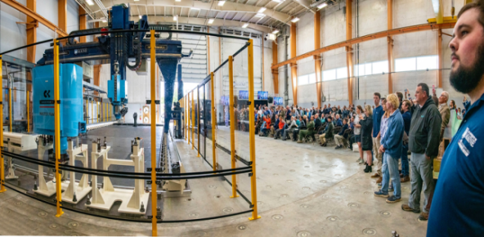
- Awarded three Guinness World Records for the world’s largest prototype polymer 3D printer, largest solid 3D-printed object, and largest 3D-printed boat. The awards came after ASCC printed 3Dirigo, a 25ft marine patrol vessel weighing 5,000lbs in under 3 days. Read more about this accomplishment
Largest polymer 3D printer in the world, commissioned at ASCC in Q4 2019. The print volume is 60 ft x 22ft x 10ft, and deposition rate is 150 lbs/hour.
- First large-scale bio-based additive manufacturing program in the US, via a $20M additive manufacturing program with Oak Ridge National Lab to work with the forest products industry to produce new bio-based materials that will be conducive to 3D printing large-scale products such as boat hull molds, shelters, building components, tooling for composites and wind blades. Read more about this accomplishment
- Selected to lead the $14.2 million Transportation Infrastructure Durability Center with 5 other universities across New England to develop more sustainable, transformative, and economical solutions to address our nation’s infrastructure challenges. Read more about this accomplishment

Purpose: The purpose of this position is to direct, manage and oversee all engineering for a program or multiple research projects as well as to identify industrial partners in the composites industry and to develop proposals for federal, state, and industry-funded R&D and demonstration programs in cooperation with industry partners.

Essential Duties & Responsibilities:
Technical Competency
  - Develops and produces textiles for use in structures and composites.
  - Designs, manages, and supervises engineering analysis, design, and testing aspects of textiles in structures and composites.
  - Conducts managerial duties in keeping research project on time and meeting objectives.
  - Manages manufacturing process development.
  - Develops, writes, and approves work instructions and executes drafts as required.
  - Provides weekly, quarterly, and monthly progress reports to clients and sponsors.
  - Writes industrial contract proposals and proposals for grants and other contracts.
  - Writes patent applications.
  - Writes and approves interim and final reports to clients and sponsors.
  - Conducts presentations of research and testing results and writes technical reports and papers for journals, periodicals, conferences, clients, sponsors, and team members.
  - Manages resources of the Engineered Materials Textile Lab (EMTL) of the Advanced Structures and Composites Center (ASCC) for growth and expansion
  - Assists in making the new EMTL a national resource for industrial and defense programs.
  - Attracts grant work by actively contacting potential clients and drafting written proposals to meet their needs.
  - Represents EMTL and ASCC at national technical meetings and trade shows.
  - Makes decisions that ensure the direct success of more than one project or task in a program.
  - Analyzes carefully to reduce risk to safety and to research funding.
  - Communicates with vendors to establish purchase specifications for research and testing materials, non-capital equipment and capital equipment.
  - Engages clientele in commercialization of ASCC developed technologies.
  - Involves ASCC personnel/faculty as necessary in proposal writing process to obtain funding.
  - Establishes collaborative relationships with prospective clients and sponsors.
  - Conducts conference calls, visits and meetings with clients and sponsors.
  - Requires an elevated level of contact with students, upper-level professionals, and administrative staff to work through situations of consequence.
  - Maintains a positive public image of the university, especially during external relations with clients and industry partners. If issues or problems arise, the positive or negative consequences are likely to become widely known (internally and externally) and materially affect the reputation of the university.
Teamwork:
  - Participates in and leads the determination of project staffing requirements, conducts interviews, leads the search committee, and facilitates the hiring process with the workforce coordinator.
  - Supervises and guides project staff including professional and classified staff as well as graduate and undergraduate students.
  - Provides safety and environmental management supervision and advice for graduate and undergraduate students.

Continued Education:
- Pursue advanced educational and training opportunities.
- Keep informed with the latest advancements in textile research and technologies.
- Attend professional meeting, webinars, and conferences.

Fiscal Responsibility:
- Analyzes program budgets, approves expenditures, and makes recommendations based on evaluation of fiscal status on accounts totaling up to or exceeding $1M.
- Approves purchase of non-capital and minor capital equipment, materials and supplies for use in research projects.
Perform other reasonably related duties as assigned.

Knowledge & Skill Qualifications:

Required:
- An M.S. in engineering with substantial industrial experience.
- Significant experience in-plant or manufacturing environment experience in some of the following areas: setting up and running weaving or knitting looms, designing knit, woven, non-woven or braided fabrics, polymer fiber extrusion and compounding, spinning of fibers, fabric finishing or coating.
- Excellent oral and written communication skills.
- Demonstrated ability to manage multiple projects and meet constant deadlines.
- Demonstrated ability to interact with industry members.
Preferred:
- A Ph.D. in Textiles, or a Ph.D. in engineering or materials science with experience in textile manufacture is strongly.
- More than 5 years of relevant professional experience.
- Experience advising and directing student research.
- Demonstrated ability to successfully lead a team of engineers in the performance of research or engineering projects.

Position Type: Contingent on funding and successful performance.

Work Schedule: Normal University of Maine business hours are Monday through Friday 8:00 a.m. to 4:30 p.m. Due to the nature of the position, work beyond regular hours (to include evenings and weekends) will be necessary to meet the requirements of the position. The employee shall establish regular office hours and in consultation with the supervisor, adjust the work schedule as appropriate.

Work Environment: Work will be performed at the Advanced Structures and Composites Center 87,000 ft2 laboratory with a world-leading team of over 350 faculty, staff and students who conduct contract research with a variety of public and private entities developing the next generation of low-cost, high performance composite materials.

Schedule for Evaluation: In the initial six months of employment and annually thereafter in accordance with the UMPSA agreement.

Job Family 07 / Salary Band 08.

The finalist for this position must successfully complete a pre-employment physical. Appropriate background checks will be required.

All UMS employees are required to comply with applicable policies and procedures, as well as to complete applicable workplace related screenings, and required employee trainings, such as Information Security, Safety Training, Workplace Violence and Sexual Harassment.

