University of Maine
Job Description
U.S. Persons Only

TITLE: Engineer III-VI Computational Solid Mechanics
DEPARTMENT: Advanced Structures & Composites Center
DATE: June 15, 2021
REPORTS TO: Senior Program Manager

Introduction to the Advanced Structures and Composites Center
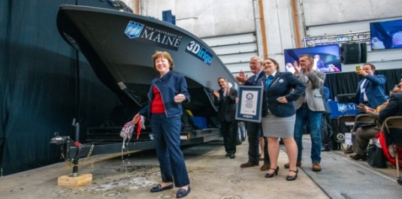
The Advanced Structures and Composites Center (ASCC) is a world-leading, interdisciplinary center for research, education, and economic development encompassing material sciences, advanced manufacturing and engineering of composites and structures. Housed in a 100,000ft² ISO-17025 accredited facility, the ASCC has been recognized nationally and internationally for cutting edge research programs leading and impacting new industries including offshore wind and marine energy, civil infrastructure, bio-based large-scale 3D printing, soldier protection systems and innovative defense-related applications. The ASCC is the largest university-based research Center in Maine, and one of the fastest growing research laboratories in the world, with research revenue growth of 5X in the past 5 years. Facility has expanded to include 13 integrated laboratories with more than 260 full and part time personnel, including faculty, staff and students. Since its founding in 1996 with support from the National Science Foundation, the Center has financially sponsored more than 2,600 students, received 70 patents, received over 26,000 visitors, created 14 spinoff companies through licensing of patents or trade secrets, and received more than 40 national and global awards for research excellence.
3Dirigo, a 25 ft. long, 5,000lbs patrol boat printed by UMaine in 72 hours, winning a Guinness World Record.
ASCC secured $150 million commitment to build a 10-12MW floating turbine using its patented VolturnUS technology.

The ASCC’s 2020 Strategic Plan, called GEM, focuses the Center’s work on Green Energy and Materials development. Through GEM, the Center is at the forefront of major new sustainability industries in the U.S., including these recent successful initiatives:

- Floating offshore wind technology developed at the ASCC led to a $100 million investment by global energy heavyweights Diamond Offshore Wind and RWE Renewables, and $50 million investment from the US DOE, to launch the first full-scale floating offshore wind project off the Maine coast. Read more about this accomplishment
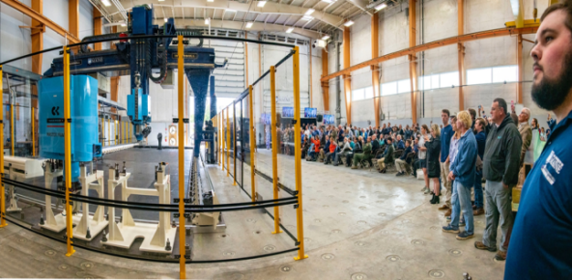
- Awarded three Guinness World Records for the world’s largest prototype polymer 3D printer, largest solid 3D-printed object, and largest 3D-printed boat. The awards came after ASCC printed 3Dirigo, a 25ft marine patrol vessel weighing 5,000lbs in under 3 days. Read more about this accomplishment
Largest polymer 3D printer in the world, commissioned at ASCC in Q4 2019. The print volume is 60 ft x 22ft x 10ft, and deposition rate is 150 lbs/hour
- First large-scale bio-based additive manufacturing program in the US, via a $20M additive manufacturing program with Oak Ridge National Lab to work with the forest products industry to produce new bio-based materials that will be conducive to 3D printing large-scale products such as boat hull molds, shelters, building components, tooling for composites and wind blades. Read more about this accomplishment
- Selected to lead the $14.2 million Transportation Infrastructure Durability Center with 5 other universities across New England to develop more sustainable, transformative and economical solutions to address our nation’s infrastructure challenges. Read more about this accomplishment

Purpose: The University of Maine Advanced Structures and Composites Center has an immediate need to hire highly qualified Engineers at the III-VI level to support our continued growth in the areas of Computational Solid Mechanics related to additive manufacturing, composite material development and applications, and bio-based materials. This position will develop theory and computational tools to support design and analysis of composite structures. The Engineer III-VI will contribute to development of proposals for federal, state, and industry-funded R&D and demonstration programs, in cooperation with industry partners.

Essential Duties & Responsibilities:
Scope:
  - Development and application of theory in solid mechanics for composites.
  - Designs, manages and supervises engineering analysis for a variety of R&D projects with a specific focus on additive manufacturing.
  - Reviews processing methods and materials and develops and implements improvements.
  - Participates in providing weekly, quarterly and monthly progress reports to the program manager as well as to clients and sponsors.
  - Contributes to the development of proposals.
  - Writes patent applications.
  - Documents technical progress for interim and final reports to clients and sponsors.
  - Creates presentations of research, writes technical reports and papers for journals, periodicals, conferences, clients, sponsors and team members.
Impact:
  - Position responsibilities and decisions toward final results impact the direction and/or success of the project or research funding.
  - Participates in strategic planning meetings for Advanced Structures and Composites Center.
  - Position responsibilities and decisions toward final results impact the direction and/or success of more than one project or task in a program.
  - Substantial analysis is required in decision making and many factors must be weighed before a decision can be reached because errors are not typically apparent and could result in significant costs or create a serious safety issue/concern.
Contacts:
  - Instructs and advises professional staff, classified staff, and undergraduate students.
  - Interfaces with collaborative partners to advance research goals.
  - Participates in conference calls, visits, and meetings with subcontractors, clients and sponsors.
  - Has significant impact on the public image of the university because external relations with clients and industry partners. If issues or problems arise, the positive or negative consequences are likely to become widely known (internally and externally) and materially affect the reputation of the university.
Authority:
  - Mentor and guides staff members, graduate research assistants, and undergraduate research assistants in completing, executing, and planning R&D projects.
  - Coordinates with team members to complete research program plans.
  - Provides safety and environmental management supervision and advice for graduate and undergraduate students.

Perform other reasonably related duties as assigned.

Knowledge & Skill Qualifications:

Required:
- M.S. in related Engineering field, in mechanical engineering, civil engineering or related discipline with five plus years of relevant experience in a professional or academic research environment or an equivalent combination of education and experience.
- Significant experience in computational mechanics of materials.
- Significant experience in composite design and engineering.
- Experience in some of the following areas: FEA theory, composite materials and manufacturing methods, thermoplastic composites design, additive manufacturing (3D Printing), advanced mechanics of materials, and software development.
- Excellent oral and written communication skills required.
- Demonstrated ability to manage multiple projects and meet constant deadlines.
- Demonstrated ability to interact with industry members.

Preferred:
- Ph.D. in related Engineering fields, polymer engineering, chemical engineering, mechanical engineering, material science, physics, or a related discipline would be an advantage.
- P.E.
- Experience mentoring and directing staff and students desired.

Position Type: Contingent on funding and successful performance.

Work Schedule: Normal University of Maine business hours are Monday through Friday 8:00 a.m. to 4:30 p.m. Due to the nature of the position, work beyond regular hours (to include evenings and weekends) will be necessary to meet the requirements of the position. The employee shall establish regular office hours and in consultation with the supervisor, adjust the work schedule as appropriate. This position is considered Essential Personnel in the ASCC Storm Day Policy.

Work Environment: Work will be performed at either locations of the Advanced Structures and Composites Center. Our 100,000 ft2 laboratory located in Orono, Maine or our satellite office located in Portland ME. Please specify on your cover letter which location you prefer to be considered for. You will work with a world-leading team of over 150 faculty, staff and students who conduct contract research with a variety of public and private entities developing the next generation of low-cost, high performance composite materials.

Schedule for Evaluation: In the initial six months of employment and annually thereafter in accordance with the UMPSA agreement.

Salary: This position falls within the Salary bands 7,8,9,10

Engineer III up to $102,560
Engineer IV up to $117,944
Engineer V up to $135,635
Engineer VI up to $155,980

Appropriate background checks will be required and the finalist for this position must successfully complete a pre-employment physical.

All UMS employees are required to comply with applicable policies and procedures, as well as to complete applicable workplace related screenings, and required employee trainings, such as Information Security, Safety Training, Workplace Violence and Sexual Harassment.

