University of Maine
Job Description

TITLE: Engineer III-VI - Marine Systems Design
DEPARTMENT: Advanced Structures & Composites Center
DATE: September 22, 2021
REPORTS TO: Senior Program Manager

Introduction to the Advanced Structures and Composites Center
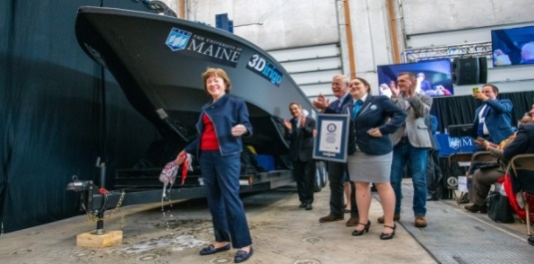
The Advanced Structures and Composites Center (ASCC) is a world-leading, interdisciplinary center for research, education, and economic development encompassing material sciences, advanced manufacturing and engineering of composites and structures. Housed in a 100,000ft² ISO-17025 accredited facility, the ASCC has been recognized nationally and internationally for cutting edge research programs leading and impacting new industries including offshore wind and marine energy, civil infrastructure, bio-based large-scale 3D printing, soldier protection systems and innovative defense-related applications. The ASCC is the largest university-based research Center in Maine, and one of the fastest growing research laboratories in the world, with research revenue growth of 5X in the past 5 years. Facility has expanded to include 13 integrated laboratories with more than 260 full and part time personnel, including faculty, staff and students. Since its founding in 1996 with support from the National Science Foundation, the Center has financially sponsored more than 2,600 students, received 70 patents, received over 26,000 visitors, created 14 spinoff companies through licensing of patents or trade secrets, and received more than 40 national and global awards for research excellence.
3Dirigo, a 25 ft. long, 5,000lbs patrol boat printed by UMaine in 72 hours, winning a Guinness World Record.
ASCC secured $150 million commitment to build a 10-12MW floating turbine using its patented VolturnUS technology.

The ASCC’s 2020 Strategic Plan, called GEM, focuses the Center’s work on Green Energy and Materials development. Through GEM, the Center is at the forefront of major new sustainability industries in the U.S., including these recent successful initiatives:

- Floating offshore wind technology developed at the ASCC led to a $100 million investment by global energy heavyweights Diamond Offshore Wind and RWE Renewables, and $50 million investment from the US DOE, to launch the first full-scale floating offshore wind project off the Maine coast. Read more about this accomplishment
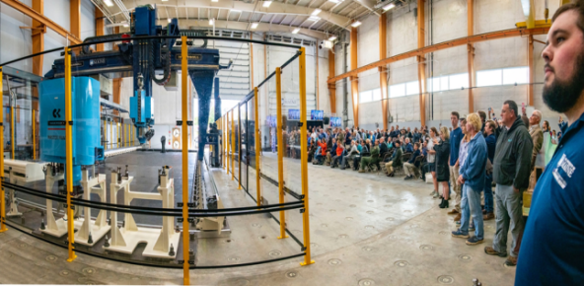
- Awarded three Guinness World Records for the world’s largest prototype polymer 3D printer, largest solid 3D-printed object, and largest 3D-printed boat. The awards came after ASCC printed 3Dirigo, a 25ft marine patrol vessel weighing 5,000lbs in under 3 days. Read more about this accomplishment
Largest polymer 3D printer in the world, commissioned at ASCC in Q4 2019. The print volume is 60 ft x 22ft x 10ft, and deposition rate is 150 lbs/hour
- First large-scale bio-based additive manufacturing program in the US, via a $20M additive manufacturing program with Oak Ridge National Lab to work with the forest products industry to produce new bio-based materials that will be conducive to 3D printing large-scale products such as boat hull molds, shelters, building components, tooling for composites and wind blades. Read more about this accomplishment
- Selected to lead the $14.2 million Transportation Infrastructure Durability Center with 5 other universities across New England to develop more sustainable, transformative and economical solutions to address our nation’s infrastructure challenges. Read more about this accomplishment
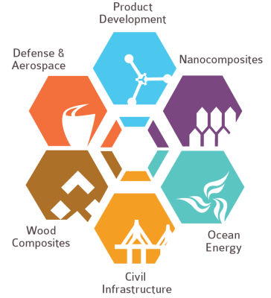
Purpose: The University of Maine Advanced Structures and Composites Center has an immediate need to hire a highly-qualified Engineer III-VI to support our continued growth in the area of hybrid manufacturing of marine end use parts and vessels. The purpose of this position is to provide support in evaluating, designing, and improving marine systems for vessels comprised of composite materials from large-scale hybrid manufacturing approaches. The Engineer III-VI will support, plan, and conduct assigned and/or original research in a variety of research and development projects encompassing manufacturing, marine engineering and systems, and the engineering of composites and structures while working collaboratively with faculty, staff, and graduate and undergraduate students at the Advanced Structures and Composites Center. The Engineer III-VI will additionally collaborate with external vendors to manage the installation of novel machinery systems into prototype and experimental vessels and laboratory test setups.

Essential Duties & Responsibilities:
Scope:
  - Conducts managerial duties in keeping research project on time and meeting objectives
  - Design, engineering and material testing to support marine applications and a variety of other Center R&D projects as needed
  - Recommends and designs tests to be conducted to fit the client’s needs
  - Manages procurement, outfit, and testing phases of system installation(s)
  - Aids planning of system operation, inspection, and maintenance as needed for operational lifespan of system
  - Develops, writes and approves work instructions and executes drafts as required
  - Provides weekly, quarterly and monthly progress reports to clients and sponsors
  - Writes industrial contract proposals and proposals for grants and other contracts
  - Writes patent applications
  - Writes and approves interim and final reports to clients and sponsors
  - Conducts presentations of research and testing results and writes technical reports and papers for journals, periodicals, conferences, clients, sponsors and team members
  - Develops and maintains updated Gantt charts for projects
Impact:
  - Leads complex specialized analysis of vessel systems
  - Supports overall vessel design cycles, integrating with structural and naval architectural teams
  - Manages Advanced Structures and Composites Center program resources for growth and expansion
  - Attracts grant work by actively contacting potential clients and drafting written proposals to meet their needs
  - Position responsibilities and decisions towards final results impact the direct success of more than one project or task in a program
  - Substantial analysis is required in the decision making process and errors are not typically apparent and could result in significant risk to research funding or create a serious safety issue/concern
Contacts:
  - Communicates with vendors to establish purchase specifications for research and testing materials, non-capital equipment and capital equipment
  - Engages clientele in commercialization of Advanced Structures and Composites Center developed technologies
  - Involves Advanced Structures and Composites Center personnel/faculty as necessary in proposal writing process to obtain funding
  - Establishes collaborative relationships with prospective clients and sponsors
  - Conducts conference calls, visits and meetings with clients and sponsors
  - Requires a high level of contact with students, upper level professional and administrative staff to work through situations of consequence
  - Has significant impact on the public image of the university because external relations with clients and industry partners. If issues or problems arise, the positive or negative consequences are likely to become widely known (internally and externally) and materially affect the reputation of the university
Authority:
  - Participates in determination of project staffing requirements, conducts interviews, leads search committee, and facilitates hiring process
  - Supervises and guides project staff including professional and classified staff as well as graduate and undergraduate students
  - Provides safety and environmental management supervision and advice for graduate and undergraduate students

Fiscal Responsibility:
- Monitors (reviews and checks for accuracy) program budgets totaling up to or exceeding $1.5M
- Analyzes program budgets, approves expenditures, and makes recommendations based on evaluation of fiscal status on accounts totaling up to or exceeding $1M
- Administers project budgets, plans and forecasts future expenditures, and approves transactions on accounts totaling up to or exceeding $450K
- Approves purchase of non-capital and minor capital equipment, materials and supplies for use in research projects

Performs other reasonably related duties as assigned.

Knowledge & Skill Qualifications:
Required:
- M.S. in related engineering fields, structural engineering, naval architecture, chemical engineering, mechanical engineering, material science, physics, or a related discipline. Or Bachelor’s degree plus significant relevant experience.
- Three or more years’ experience in maritime industry, preferably from design and/or initial build backgrounds.
- Familiarity with composite vessel build process, which may include system component sizing and layout, part tooling design and implementation, lamination processes, and manufacturing challenges.
- Excellent oral and written communication skills.
- Demonstrated ability to manage multiple projects and meet constant deadlines.
- Demonstrated ability to interact with industry members.

Preferred:
- Significant experience in some of the following areas: advanced composites, FEA, design for additive manufacturing (3D printing), marine composite fabrication, systems and assembly, advanced mechanics of materials, would be an advantage
- Experience with marine electrical propulsion systems preferred.
- Experience with planning and execution of operations and maintenance of marine systems preferred.

Position Type: Contingent on funding and successful performance.

Work Schedule: Normal University of Maine business hours are Monday through Friday 8:00 a.m. to 4:30 p.m. Due to the nature of the position, work beyond regular hours (to include evenings and weekends) will be necessary to meet the requirements of the position. The employee shall establish regular office hours and in consultation with the supervisor, adjust the work schedule as appropriate. This position is considered Essential Personnel in the ASCC Storm Day Policy.

Work Environment: Work will be performed at the Advanced Structures and Composites Center 87,000 ft2 laboratory with a world-leading team of over 150 faculty, staff and students who conduct contract research with a variety of public and private entities developing the next generation of low-cost, high performance composite materials.

Schedule for Evaluation: In the initial six months of employment and annually thereafter in accordance with the UMPSA agreement.

Appropriate background checks and pre-employment physical are required.

All UMS employees are required to comply with applicable policies and procedures, as well as to complete applicable workplace related screenings, and required employee trainings, such as Information Security, Safety Training, Workplace Violence and Sexual Harassment.

