University of Maine
Job Description

TITLE: Engineer III-IV, Business Development/Commercialization Manager for Floating Offshore Wind Technologies
DEPARTMENT: Advanced Structures & Composites Center
DATE: November 30, 2021
REPORTS TO: Chief Engineer, Offshore Wind Technologies

Introduction to the Advanced Structures and Composites Center
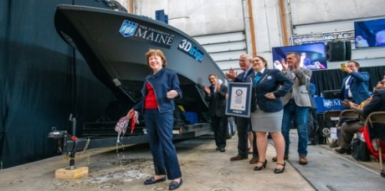
The Advanced Structures and Composites Center (ASCC) is a world-leading, interdisciplinary center for research, education, and economic development encompassing material sciences, advanced manufacturing and engineering of composites and structures. Housed in a 100,000ft² ISO-17025 accredited facility, the ASCC has been recognized nationally and internationally for cutting edge research programs leading and impacting new industries including offshore wind and marine energy, civil infrastructure, bio-based large-scale 3D printing, soldier protection systems and innovative defense-related applications. The ASCC is the largest university-based research Center in Maine, and one of the fastest growing research laboratories in the world, with research revenue growth of 5X in the past 5 years. Facility has expanded to include 13 integrated laboratories with more than 260 full and part time personnel, including faculty, staff and students. Since its founding in 1996 with support from the National Science Foundation, the Center has financially sponsored more than 2,600 students, received 70 patents, received over 26,000 visitors, created 14 spinoff companies through licensing of patents or trade secrets, and received more than 40 national and global awards for research excellence.
3Dirigo, a 25 ft. long, 5,000lbs patrol boat printed by UMaine in 72 hours, winning a Guinness World Record.
ASCC secured $150 million commitment to build a 10-12MW floating turbine using its patented VolturnUS technology.

The ASCC’s 2020 Strategic Plan, called GEM, focuses the Center’s work on Green Energy and Materials development. Through GEM, the Center is at the forefront of major new sustainability industries in the U.S., including these recent successful initiatives:

- Floating offshore wind technology developed at the ASCC led to a $100 million investment by global energy heavyweights Diamond Offshore Wind and RWE Renewables, and $50 million investment from the US DOE, to launch the first full-scale floating offshore wind project off the Maine coast. Read more about this accomplishment
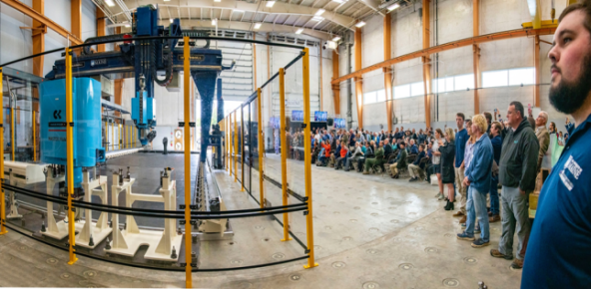
- Awarded three Guinness World Records for the world’s largest prototype polymer 3D printer, largest solid 3D-printed object, and largest 3D-printed boat. The awards came after ASCC printed 3Dirigo, a 25ft marine patrol vessel weighing 5,000lbs in under 3 days. Read more about this accomplishment
Largest polymer 3D printer in the world, commissioned at ASCC in Q4 2019. The print volume is 60 ft x 22ft x 10ft, and deposition rate is 150 lbs/hour
- First large-scale bio-based additive manufacturing program in the US, via a $20M additive manufacturing program with Oak Ridge National Lab to work with the forest products industry to produce new bio-based materials that will be conducive to 3D printing large-scale products such as boat hull molds, shelters, building components, tooling for composites and wind blades. Read more about this accomplishment
- Selected to lead the $14.2 million Transportation Infrastructure Durability Center with 5 other universities across New England to develop more sustainable, transformative and economical solutions to address our nation’s infrastructure challenges. Read more about this accomplishment

Purpose: The purpose of this position is to manage, execute, and advance business opportunities for the University of Maine’s developed floating offshore wind related technologies and technical services.

This position requires excellent communication, technical competence, and business skills to effectively advance the use of UMaine offshore wind technology to end users.

Essential Duties & Responsibilities:
Scope:
  - Identifies business development opportunities of the floating offshore wind related technologies
  - Prepares technical and sales information
  - Develops and executes marketing strategies
  - Collaborates with management related to commercialization efforts within the program
  - Participates in providing weekly, quarterly and monthly progress reports to the program manager as well as to clients and sponsors
  - Supports ASCC program milestones communicating with potential industrial contacts and partners, scheduling meetings, maintaining communication, developing agendas, executing and preparing related reports, detailed technical presentations for program deliverables
  - Coordinating technical information packages working with a team and ensuring client satisfaction
  - Maintains records of IP portfolio and interfaces with UMaine commercialization office
  - Maintains up to date technology technical and sales packages for use with customer engagement
Impact:
  - Acts a primary interface with new business opportunities and manages responses/ interaction
  - Provides and reviews monthly progress reports to the program manager as well as to clients and sponsors
  - Position responsibilities and decisions toward final results impact the direction and/or success of the project or research funding
  - Available guides or precedents are limited in decision making and errors are not typically apparent
Contacts:
  - Works directly with clients of interest to develop the use case for technologies, scopes of work (SOW) and budgets for new projects
  - Instructs and advises professional and classified staff as well as undergraduate students referencing the advancement of offshore wind technologies and technical services
  - Supports ASCC Management team discussions relating to future strategy through industry contacts and keeping abreast with technological developments in the industry
  - Supports development of presentations for reporting and communications purposes
  - Executes the development of meetings, workshops and conferences conducted by the UM ASCC
  - Participates in conference calls, visits, and meetings with subcontractors, clients and sponsors
  - Has significant impact on the public image of the university because external relations with clients and industry partners
    - If issues or problems arise, the positive or negative consequences are likely to become widely known (internally and externally) and materially affect the reputation of the university
Authority:
  - Coordinates teams and assigns tasks for completing program plans to advance technologies. Ensures successful delivery of tasks
  - Advises and assists technical and business staff to execute work
  - Student intern supervision

Fiscal Responsibility:
  - Monitors (reviews and checks for accuracy) program budgets totaling up to or exceeding $1M
  - Analyzes (critically review budgetary data) program budgets totaling up to or exceeding $750K and recommends spending dollars accordingly
  - Administers (forecasts and controls spending) program budgets totaling up to or exceeding $150K and determines spending accordingly

Performs other reasonably related duties as assigned

Knowledge & Skill Qualifications:

Required:
- M.S. in related Science/Engineering field – Civil Engineering, Mechanical Engineering, Ocean or Wind Engineering, with 5-10 years of relevant experience in a professional or academic research environment or an equivalent combination of education and experience necessary to complete the position
- Excellent oral and written communication skills
- Demonstrated ability to manage multiple projects and meet constant deadlines
- Project management experience
- Demonstrated ability to interact with industry members
- US Person.

Preferred:
- Experience in business development relevant to Engineering Research and Development
- Ability to synthesize technical information and relay content to customers
- Ability to lead technical teams to deliver information to customers on time
- Experience developing and presenting technical and business sales proposals

Position Type: Contingent on funding and successful performance.

Work Schedule: Normal University of Maine business hours are Monday through Friday 8:00 a.m. to 4:30 p.m. Due to the nature of the position, work beyond regular hours (to include evenings and weekends) will be necessary to meet the requirements of the position. The employee shall establish regular office hours and in consultation with the supervisor, adjust the work schedule as appropriate. This position is considered Essential Personnel in the ASCC Storm Day Policy.

Work Environment: Work will be performed at the Advanced Structures and Composites Center 100,000 ft² laboratory with a world-leading team of over 150 faculty, staff and students who conduct contract research with a variety of public and private entities developing the next generation of low-cost, high performance composite materials.

Schedule for Evaluation: In the initial six months of employment and annually thereafter in accordance with the UMPSA agreement.

Job Family/Salary Band: JF 07 / Engineer III SB 07, Engineer IV SB 08

The finalist for this position must successfully complete a pre-employment physical.

All UMS employees are required to comply with applicable policies and procedures, as well as to complete applicable workplace related screenings, and required employee trainings, such as Information Security, Safety Training, Workplace Violence and Sexual Harassment.

Appropriate background checks will be required.

