University of Maine
Job Description
U.S. Persons Only

TITLE: Engineer II-IV - Instrumentation Wind Wave Ocean Engineering Lab
DEPARTMENT: Advanced Structures & Composites Center
DATE: March 18, 2022
REPORTS TO: Engineer V, Wind Wave Basin Manager

Introduction to the Advanced Structures and Composites Center
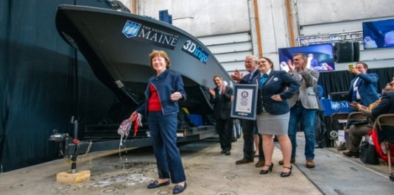
The Advanced Structures and Composites Center (ASCC) is a world-leading, interdisciplinary center for research, education, and economic development encompassing material sciences, advanced manufacturing and engineering of composites and structures. Housed in a 100,000ft² ISO-17025 accredited facility, the ASCC has been recognized nationally and internationally for cutting edge research programs leading and impacting new industries including offshore wind and marine energy, civil infrastructure, bio-based large-scale 3D printing, soldier protection systems and innovative defense-related applications. The ASCC is the largest university-based research Center in Maine, and one of the fastest growing research laboratories in the world, with research revenue growth of 5X in the past 5 years. Facility has expanded to include 13 integrated laboratories with more than 260 full and part time personnel, including faculty, staff and students. Since its founding in 1996 with support from the National Science Foundation, the Center has financially sponsored more than 2,600 students, received 70 patents, received over 26,000 visitors, created 14 spinoff companies through licensing of patents or trade secrets, and received more than 40 national and global awards for research excellence.
3Dirigo, a 25 ft. long, 5,000lbs patrol boat printed by UMaine in 72 hours, winning a Guinness World Record.
ASCC secured $150 million commitment to build a 10-12MW floating turbine using its patented VolturnUS technology.

The ASCC’s 2020 Strategic Plan, called GEM, focuses the Center’s work on Green Energy and Materials development. Through GEM, the Center is at the forefront of major new sustainability industries in the U.S., including these recent successful initiatives:

- Floating offshore wind technology developed at the ASCC led to a $100 million investment by global energy heavyweights Diamond Offshore Wind and RWE Renewables, and $50 million investment from the US DOE, to launch the first full-scale floating offshore wind project off the Maine coast. Read more about this accomplishment
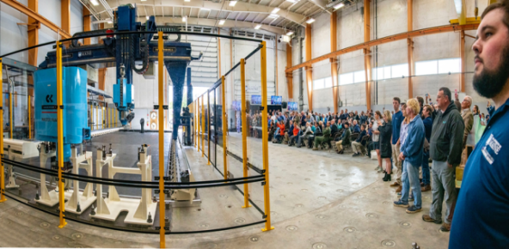
- Awarded three Guinness World Records for the world’s largest prototype polymer 3D printer, largest solid 3D-printed object, and largest 3D-printed boat. The awards came after ASCC printed 3Dirigo, a 25ft marine patrol vessel weighing 5,000lbs in under 3 days. Read more about this accomplishment
Largest polymer 3D printer in the world, commissioned at ASCC in Q4 2019. The print volume is 60 ft x 22ft x 10ft, and deposition rate is 150 lbs/hour
- First large-scale bio-based additive manufacturing program in the US, via a $20M additive manufacturing program with Oak Ridge National Lab to work with the forest products industry to produce new bio-based materials that will be conducive to 3D printing large-scale products such as boat hull molds, shelters, building components, tooling for composites and wind blades. Read more about this accomplishment
- Selected to lead the $14.2 million Transportation Infrastructure Durability Center with 5 other universities across New England to develop more sustainable, transformative and economical solutions to address our nation’s infrastructure challenges. Read more about this accomplishment

Purpose: The purpose of this position is to support a variety of testing and R&D projects related to design, development, and testing of offshore structures, while helping to maintain and schedule service of existing equipment in the Wind Wave Ocean Engineering Lab. Key responsibilities include design of instrumentation systems to meet project needs, data acquisition and controls software development, and developing/maintaining Wind Wave Ocean Engineering lab operating and documentation procedures to meet quality control requirements.

Essential Duties & Responsibilities:
Scope:
- Designing of instrumentation and power delivery systems (hardware specification, verification, and software development), including test plan and budget support
- Developing and maintaining data acquisition and controls software to support project needs
- Developing and maintaining lab operating procedures to meet data quality requirements
- Providing troubleshooting expertise during design, installation, and commissioning of equipment
- Working with Principal Investigators and Project Managers to develop work instructions and executes drafts as required
- Leading a small team of engineers and students to deliver high quality instrumentation and hardware solutions to support model testing
- Developing of instrumentation plans, specifications, and calibration reports to document testing work for clients
- Designing and constructing of automated machinery and control
- Participating in high-level project planning and leadership of the facility operations
- Supporting the overall goals of the Wind Wave Ocean Engineering testing team
- Training students and staff in the proper use of complex equipment in the lab
- Conducting electrical maintenance of existing lab equipment

Impact:
- Key responsibility in design, execution, and documentation of instrumentation to support testing programs
- Responsibilities and decisions impact the direction and/or success of the project deliverables

Contacts:
- Instructs and advises professional and classified staff as well as undergraduate and graduate students referencing testing and execution techniques
- Communicates with vendors to establish purchase specifications for research and testing materials, non-capital equipment, and capital equipment
Authority:
- Supervises and guides a team of graduate research assistants and undergraduate student lab assistants
- Assists and instructs staff, multiple graduate and undergraduate students in area of expertise
- Advises and assists graduate students in completing, executing, and planning R&D projects
- Provides safety and environmental management supervision and advice for graduate and undergraduate students

Fiscal Responsibility:
- Develops and maintains instrumentation budgets for testing projects
- Works effectively and cooperatively with department members, UMaine administration, the campus community, and external clients and customers

Knowledge & Skill Qualifications:
Required:
- B.S. in related Engineering field, or an equivalent combination of education and experience
- Strong electronics background including analog and digital circuits, troubleshooting, and soldering skills
- Knowledge of basic instrumentation (strain gauges, load cells, accelerometers, string potentiometers, accelerometers, LVDTs)
- Experience with MS Office and MATLAB
- Excellent organizational, oral and written communication skills
- Demonstrated ability to support multiple projects and meet constant deadlines
- Demonstrated ability to interact with industry members
- Detail oriented producing high quality work
- Ability to work independently as well as in a team environment with faculty, staff, lab technicians, management, students, and industrial clients

Preferred:
- Experience with National Instruments equipment and LabVIEW/Real-Time
- Experience with G-code, CNC, or another industrial automation programming
- Experience with CAD (SolidWorks, AutoCad)
- Working knowledge of Linux/Unix Environments
- Experience with motion capture equipment (Qualisys) and software. The ability to demonstrate proficiency within the first 6 months will be required.
- 5+ years of relevant professional experience or 3+ years of relevant professional experience and M.S. in related Engineering field

Position Type: Contingent on funding and successful performance.

Work Schedule: Normal University of Maine business hours are Monday through Friday 8:00 a.m. to 4:30 p.m. Due to the nature of the position, work beyond regular hours (to include evenings and weekends) will be necessary to meet the requirements of the position. The employee shall establish regular office hours and in consultation with the supervisor, adjust the work schedule as appropriate. This position is considered Essential Personnel in the ASCC Storm Day Policy.

Work Environment: Work will be performed at the Advanced Structures and Composites Center 100,000 ft² laboratory with a world-leading team of over 150 faculty, staff, and students who conduct contract research with a variety of public and private entities developing the next generation of low-cost, high performance composite materials.

Schedule for Evaluation: In the initial six months of employment and annually thereafter in accordance with the UMPSA agreement.

Salary: Engineer II up to $98,101
Engineer III up to $112,816
Engineer IV up to $129,738

The finalist for this position must successfully complete a pre-employment physical and appropriate background checks are required.

All UMS employees are required to comply with applicable policies and procedures, as well as to complete applicable workplace related screenings, and required employee training, such as Information Security, Safety Training, Workplace Violence, and Sexual Harassment.

