University of Maine
Job Description

TITLE: Assistant Research Professor
DEPARTMENT: Advanced Structures & Composites Center
DATE: July 15, 2021
REPORTS TO: Senior Program Manager and Principle Investigators

Introduction to the Advanced Structures and Composites Center
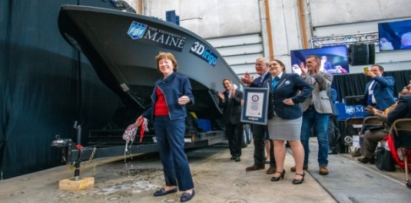
The Advanced Structures and Composites Center (ASCC) is a world-leading, interdisciplinary center for research, education, and economic development encompassing material sciences, advanced manufacturing and engineering of composites and structures. Housed in a 100,000ft² ISO-17025 accredited facility, the ASCC has been recognized nationally and internationally for cutting edge research programs leading and impacting new industries including offshore wind and marine energy, civil infrastructure, bio-based large-scale 3D printing, soldier protection systems and innovative defense-related applications. The ASCC is the largest university-based research Center in Maine, and one of the fastest growing research laboratories in the world, with research revenue growth of 5X in the past 5 years. Facility has expanded to include 13 integrated laboratories with more than 260 full and part time personnel, including faculty, staff and students. Since its founding in 1996 with support from the National Science Foundation, the Center has financially sponsored more than 2,600 students, received 70 patents, received over 26,000 visitors, created 14 spinoff companies through licensing of patents or trade secrets, and received more than 40 national and global awards for research excellence.
3Dirigo, a 25 ft. long, 5,000lbs patrol boat printed by UMaine in 72 hours, winning a Guinness World Record.
ASCC secured $150 million commitment to build a 10-12MW floating turbine using its patented VolturnUS technology.

The ASCC’s 2020 Strategic Plan, called GEM, focuses the Center’s work on Green Energy and Materials development. Through GEM, the Center is at the forefront of major new sustainability industries in the U.S., including these recent successful initiatives:

- Floating offshore wind technology developed at the ASCC led to a $100 million investment by global energy heavyweights Diamond Offshore Wind and RWE Renewables, and $50 million investment from the US DOE, to launch the first full-scale floating offshore wind project off the Maine coast. Read more about this accomplishment
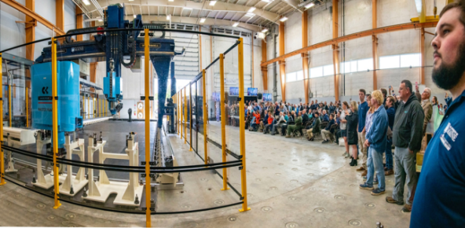
- Awarded three Guinness World Records for the world’s largest prototype polymer 3D printer, largest solid 3D-printed object, and largest 3D-printed boat. The awards came after ASCC printed 3Dirigo, a 25ft marine patrol vessel weighing 5,000lbs in under 3 days. Read more about this accomplishment
Largest polymer 3D printer in the world, commissioned at ASCC in Q4 2019. The print volume is 60 ft x 22ft x 10ft, and deposition rate is 150 lbs/hour
- First large-scale bio-based additive manufacturing program in the US, via a $20M additive manufacturing program with Oak Ridge National Lab to work with the forest products industry to produce new bio-based materials that will be conducive to 3D printing large-scale products such as boat hull molds, shelters, building components, tooling for composites and wind blades. Read more about this accomplishment
- Selected to lead the $14.2 million Transportation Infrastructure Durability Center with 5 other universities across New England to develop more sustainable, transformative and economical solutions to Address our nation’s infrastructure challenges. Read more about this accomplishment

PURPOSE: Coordinate, manage, and conduct Portland cement concrete research in collaboration with Transportation Infrastructure Durability Center (TIDC) faculty and staff, focusing on lower CO₂ concrete, as well as 3D printing of cement-based materials, and to coordinate technical issues with external constituencies.

ESSENTIAL DUTIES/RESPONSIBILITIES:

- Conduct scientific research into durability of Portland cement concrete and Portland cement concrete systems that include supplementary cementitious materials. Conduct research on minimization of overall CO2 footprint in concrete materials.
- Lead development of new research areas, such as 3D printing of cement-based materials.
- Manage research reporting and other contractual obligations.
- Maintain laboratory instrumentation for cement-based material research.
- Research and recommend purchase for equipment, materials and supplies for use in cement-based materials research projects.
- Collaborate on State and Federal contract and grant work by actively pursuing RFPs and drafting written proposals to meet needs.
- Involve TIDC personnel/faculty as necessary in proposal writing process related to cement-based materials, and to obtain funding in support of research activities.
- Supervise Undergraduate and Graduate Research Assistants to ensure validity and accuracy of experiments and testing.
- Represent TIDC at national technical meetings.
- Perform other reasonably related duties as assigned.

KNOWLEDGE AND SKILL QUALIFICATIONS:

- Ph.D. in Civil Engineering or related discipline required by date of hire.
- Detailed knowledge of ASTM and AASHTO test standards for cement and concrete.
- Hands-on experience with cement and concrete mixing, specimen preparation, and testing.
- Hands-on experience with concrete additives.
- Demonstrated excellent organizational, written and oral communication skills.
- Demonstrated judgment while working under pressure to meet constant deadlines.
- Ability to work independently as well as in a team environment.
- Applicants must be eligible to accept employment in the United States at the time the appointment is made.

SUPERVISORY RESPONSIBILITIES: Undergraduate Research Assistants, Graduate Research Assistants, and Interns.

POSITION TYPE: Contingent on funding and successful performance.

WORK SCHEDULE: Normal University of Maine business hours are Monday through Friday 8:00 a.m. to 4:30 p.m. Work outside of normal business hours will be necessary in order to complete the requirements of the position.

WORK ENVIRONMENT: Work will generally be performed at the Advanced Structures and Composites Center.

SCHEDULE FOR EVALUATION: In the initial six months of employment and annually thereafter in accordance with the AFUM agreement.

Appropriate background checks will be required.

All UMS employees are required to comply with applicable policies and procedures, as well as to complete applicable workplace related screenings, and required employee trainings, such as Information Security, Safety Training, Workplace Violence and Sexual Harassment.

