University of Maine
Job Description
US PERSON ONLY – CONTROLLED PROJECTS

TITLE: Administrative Coordinator
DEPARTMENT: Advanced Structures and Composites Center
DATE: July 12, 2022
REPORTS TO: Executive Director/Special Assistant for Strategic Initiatives

Introduction to the Advanced Structures and Composites Center
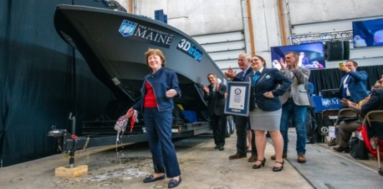
The Advanced Structures and Composites Center (ASCC) is a world-leading, interdisciplinary center for research, education, and economic development encompassing material sciences, advanced manufacturing and engineering of composites and structures. Housed in a 100,000ft² ISO-17025 accredited facility, the ASCC has been recognized nationally and internationally for cutting edge research programs leading and impacting new industries including offshore wind and marine energy, civil infrastructure, bio-based large-scale 3D printing, soldier protection systems and innovative defense-related applications. The ASCC is the largest university-based research Center in Maine, and one of the fastest growing research laboratories in the world, with research revenue growth of 5X in the past 5 years. Facility has expanded to include 13 integrated laboratories with more than 260 full and part time personnel, including faculty, staff and students. Since its founding in 1996 with support from the National Science Foundation, the Center has financially sponsored more than 2,600 students, received 70 patents, received over 26,000 visitors, created 14 spinoff companies through licensing of patents or trade secrets, and received more than 40 national and global awards for research excellence.
3Dirigo, a 25 ft. long, 5,000lbs patrol boat printed by UMaine in 72 hours, winning a Guinness World Record.

The ASCC’s 2020 Strategic Plan, called GEM, focuses the Center’s work on Green Energy and Materials development. Through GEM, the Center is at the forefront of major new sustainability industries in the U.S., including these recent successful initiatives:
ASCC received $150 million commitment from private investors and the US DOE to build a 10-12MW floating turbine using its patented VolturnUS technology.

- Floating offshore wind technology developed at the ASCC led to a $100 million investment by global energy heavyweights Diamond Offshore Wind and RWE Renewables, and $50 million investment from the US DOE, to launch the first full-scale floating offshore wind project off the Maine coast. Read more about this accomplishment
- Awarded three Guinness World Records for the world’s largest prototype polymer 3D printer, largest solid 3D-printed object, and largest 3D-printed boat. The awards came after ASCC printed 3Dirigo, a 25ft marine patrol vessel weighing 5,000lbs in under 3 days. Read more about this accomplishment
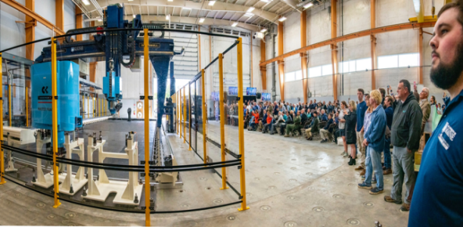
- First large-scale bio-based additive manufacturing program in the US, via a $20M additive manufacturing program with Oak Ridge National Lab to work with the forest products industry to produce new bio-based materials that will be conducive to 3D printing large-scale products such as boat hull molds, shelters, building components, tooling for composites and wind blades. Read more about this accomplishment
Largest polymer 3D printer in the world, commissioned at ASCC in Q4 2019. The print volume is 60 ft x 22ft x 10ft, and deposition rate is 150 lbs/hour
- Selected to lead the $14.2 million Transportation Infrastructure Durability Center with 5 other universities across New England to develop more sustainable, transformative and economical solutions to address our nation’s infrastructure challenges. Read more about this accomplishment

Purpose: This position is an administrative coordinator at Advanced Structures and Composites Center, providing critical administrative support and coordination, including scheduling for the Executive Director, as well as maintaining the calendar and daily preparation of meeting materials. This position is located within a fast paced and dynamic office and the ideal candidate must have the ability to multitask, balance competing priorities and address unforeseen requests. As the primary point of contact for all inquiries to the Executive Director’s Office, this position will interface internally with students, staff, faculty and administrators within the University of Maine, as well as external partners, government agencies and officials. The administrative coordinator will work closely with the Special Assistant for Strategic Initiatives in support of the Executive Director’s priorities.

Essential Duties and Responsibilities:
Scope
- Maintains Executive Director’s calendar. Schedules appointments, projects, meetings, speaking engagements, and other tasks for which the Executive Director needs to prepare.
- Serves as the first point of contact on all matters directed to the Executive Director’s office by clients, University, governmental agencies, and community constituencies.
- Assists with organization, preparation for and follow-up on internal and external Executive Director meetings, including distribution of meeting agendas, meeting minutes, and tracking action items.
- Assists with formatting and editing of formal communications (letters, memos, etc.).
- Makes all travel arrangements for the Executive Director and Special Assistant for Strategic Initiatives.
- Anticipates needs and identifies opportunities to create processes and systems to streamline office flow.
- Assesses relative urgency and relative importance of incoming issues; prioritizes and makes recommendations on course of action, and/or response in coordination with the Special Assistant for Strategic Initiatives.
- Communicates verbally and in writing on sensitive matters; frequently involving interpretation of University and ASCC policy.
- Develops and maintains professional relationships that reflect courtesy, civility, and mutual respect.
- Performs other reasonably related duties as assigned.

Contacts
- Communicates with the System Office, UMaine administrative offices, research units, UMaine academic departments, national and international media, executives in large corporations, and government agencies; including Whitehouse cabinet level staff and Senate and House staff.

Knowledge and Skill Qualifications:

Required
- Bachelor’s degree or equivalent experience in an appropriate field.
- More than five years of experience in providing executive administrative support in business, academia, or non-profit organizations.
- Ability to exercise independent judgment.
- Ability to oversee multiple administrative projects with strict deadlines and is able to adapt to high stress situations.
- Strong oral and written communications skills and the ability to work effectively with a wide range of constituencies.
- Very adept with technology, including experience with MS Word, Excel, PowerPoint, MS Project or equivalent, Google Suite, and using contacts database (CRM) or other repositories.
- Ability to work independently under the stress of deadlines with minimum supervision.
- Ability to handle and impart information of a confidential nature.
- A strong commitment to Center’s mission and goals.

Preferred
- Extensive knowledge of UMaine policies and guidelines.

Position Type: Contingent on funding and successful performance

Work Schedule: Normal University of Maine business hours are Monday through Friday 8:00 am to 4:30 pm. Work outside of regular business hours (to include nights and weekends) will be necessary at times in order to meet the requirements of the position. In consultation with the supervisor the employee will establish regular office hours and adjust work schedule as necessary. This position is considered Essential Personnel in the ASCC Storm Day Policy.

Work Environment: Work will be performed at the Advanced Structures and Composites Center 100,000 ft2 laboratory with a world-leading team of over 150 faculty, staff and students who conduct contract research with a variety of public and private entities developing the next generation of low-cost, high performance composite materials.

Schedule for Evaluation: In the initial six months of employment and annually thereafter in accordance with the UMPSA agreement.

Salary: This position is in Salary Band 02, Job Family 11.

Appropriate background checks will be required.

All UMS employees are required to comply with applicable policies and procedures, as well as to complete applicable workplace related screenings, and required employee trainings, such as Information Security, Safety Training, Workplace Violence and Sexual Harassment.

